AP Human Geography Unit 4: Political Geography Mr. Stepek
Question 1:
Map #1
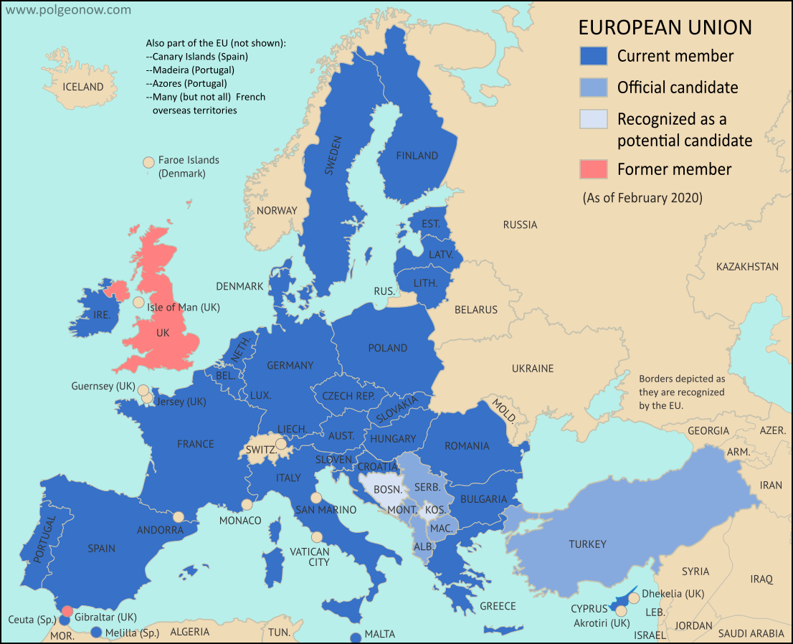

Map #2
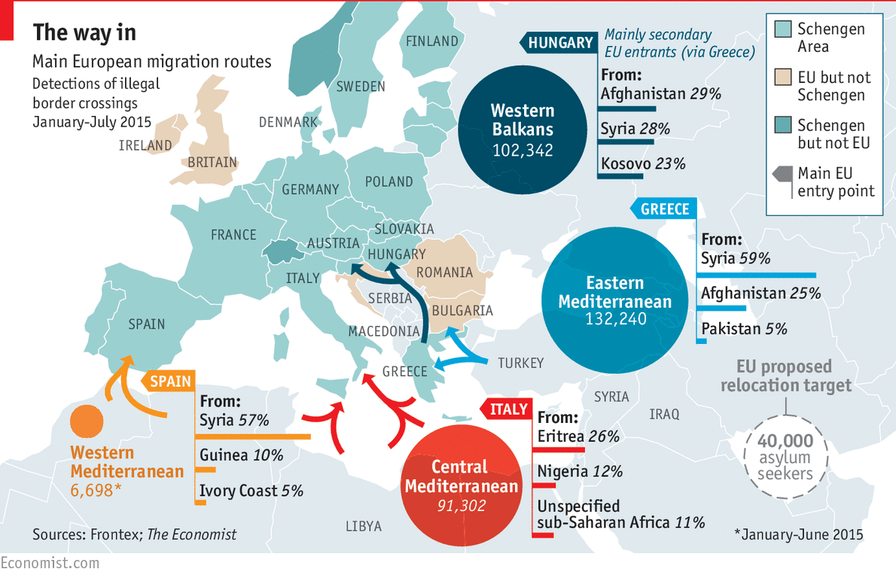

- DESCRIBE supranationalism using an example OTHER than the EU.
- DESCRIBE a characteristic of the EU which has made it a better definition of the concept of supranationalism than other examples.
- With reference to the Map #2 above, EXPLAIN one reason for why membership in a supranational organization would be a centrifugal force for a state.
- IDENTIFY the main push factor for the main European migration routes depicted in Map #2.
- DESCRIBE a different reason for why membership in a supranational organization would be a centrifugal force for a state.
- DESCRIBE one reason for why membership in that organization would be a centripetal force for a country.

Question #2
Map #1 Map #2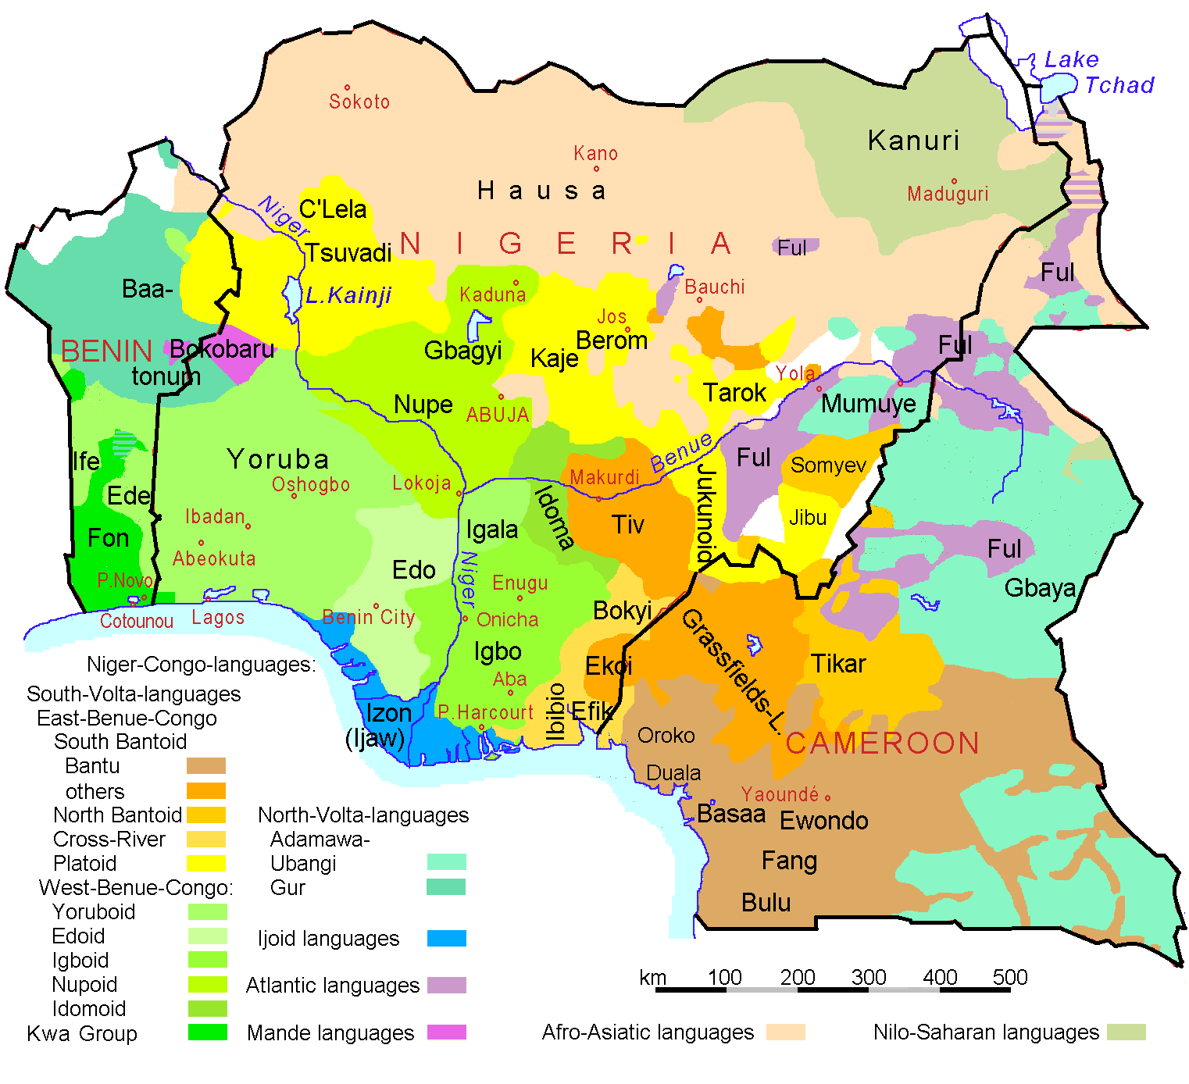 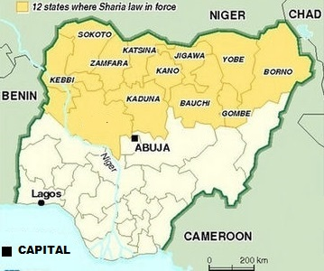

- DEFINE centrifugal and centripetal forces from a political geography perspective.
- With reference to state boundary origins, EXPLAIN a centrifugal force which affects NIgeria.
- With reference to state shape, DESCRIBE a centripetal force that affects Nigeria.
- IDENTIFY the government structure of Nigeria.
- With reference to Map #2, EXPLAIN how the government structure of Nigeria could be a centrifugal force.
- DESCRIBE (using any example) how that same government structure could be a centripetal force.

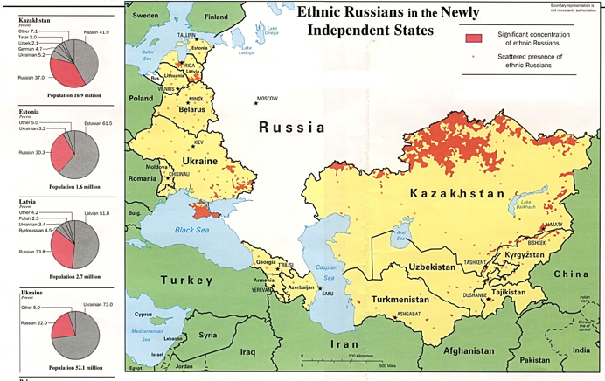
Question #3

- With reference to the map above DESCRIBE irredentism.
- EXPLAIN a centrifugal force that may affect the countries of Kazakhstan and Latvia.
- EXPLAIN how supranationalism could affect the situation in Latvia.
- IDENTIFY a migration stream from 1990s that resulted from the situation depicted in the map above.

Question #4
Item #1 Map #2
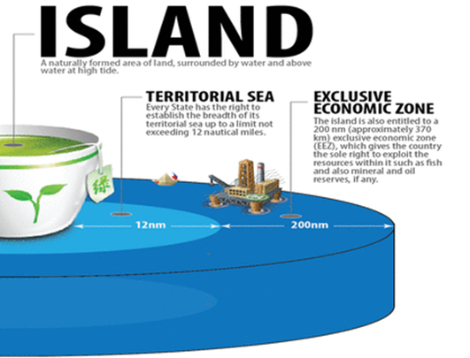
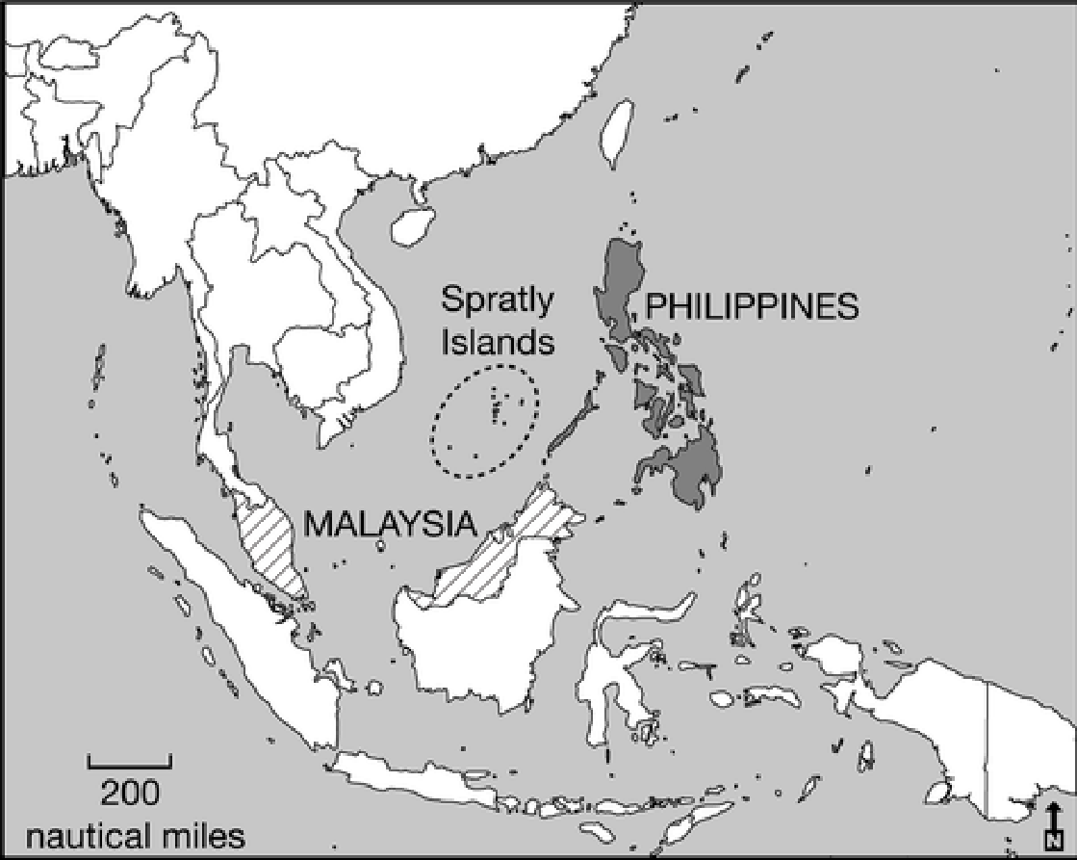

- IDENTIFY the international agreement that governs the arrangement depicted in item #1.
- COMPARE and CONTRAST the level of control which a state has over the waters within 12 miles of its shoreline and between 12 miles and 200 miles from its shoreline.
- EXPLAIN how the Spratly Islands complicate the international agreement discussed above.

Question #4 (please look at all four maps when crafting your answers)
Map #1 (post-WWII migration) Map #2
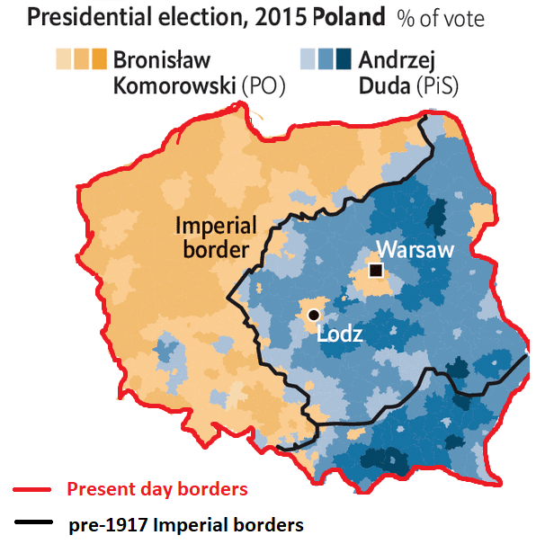
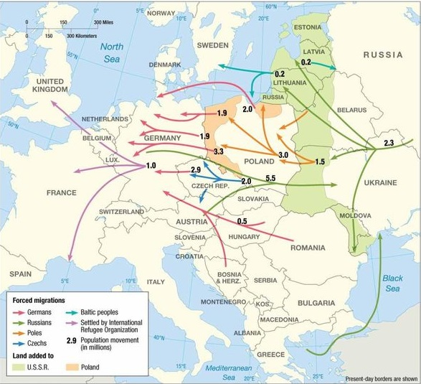

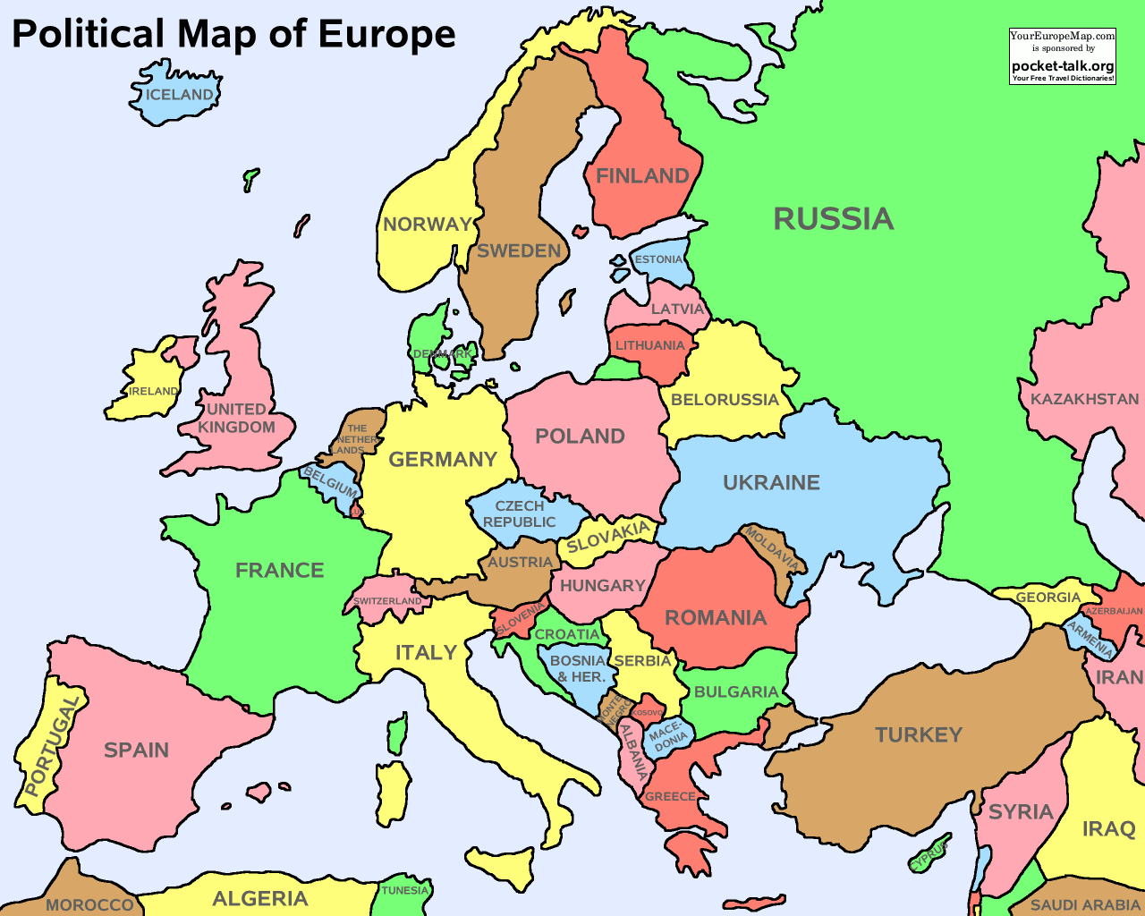
Map #3

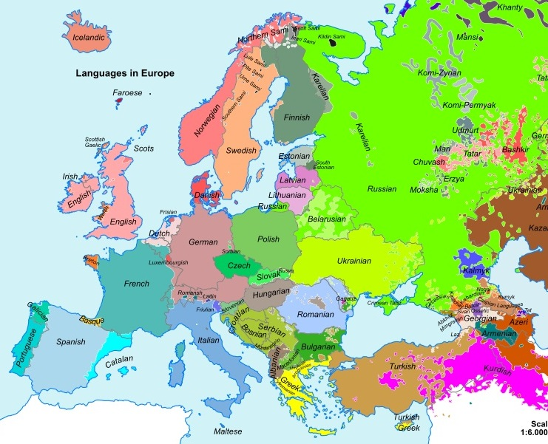
Map #4

- DEFINE the type of border/boundary creation process which resulted in the borders of present-day Poland.
- DESCRIBE the type of border/boundary evident in Map #2.
- EXPLAIN how a state within Europe reflects the characteristics of a nation-state.
- EXPLAIN how a state within Europe reflects the characteristics of a multi-national state.
- DESCRIBE how a situation within Europe reflects the characteristics of a stateless nation.
- DESCRIBE how a state within Europe reflects the characteristics of a multi-ethnic state.
- DESCRIBE an ethnic enclave within Europe.
- DESCRIBE a political exclave within Europe.

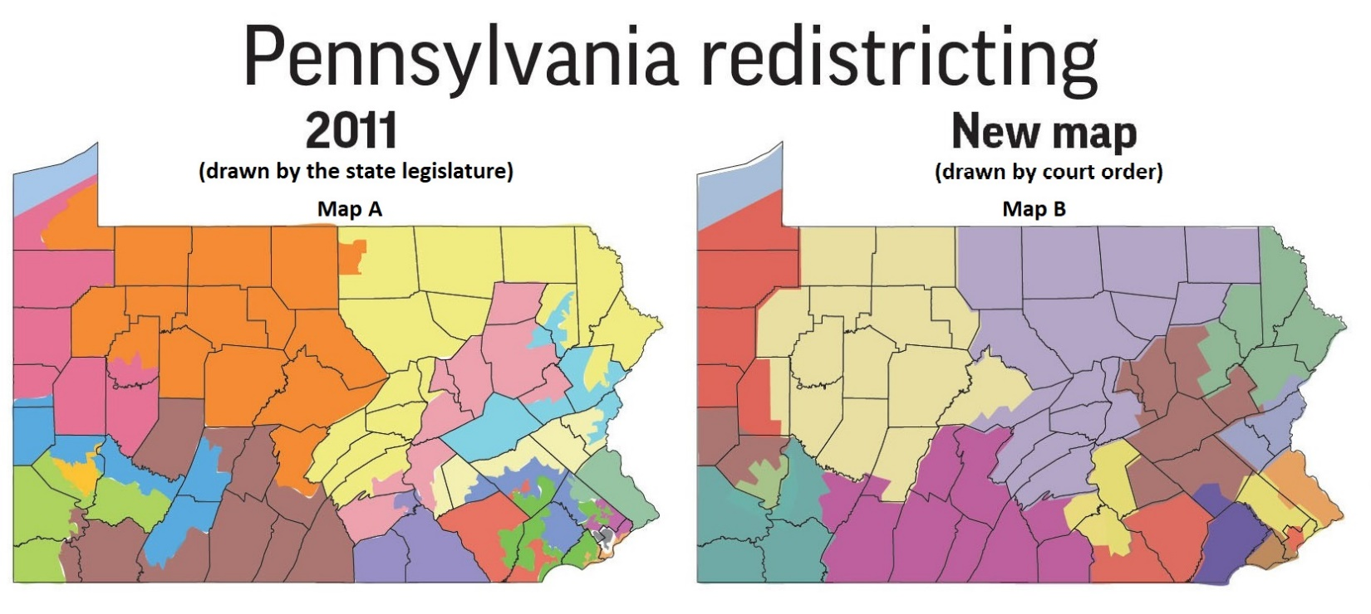
Question #5 (both maps below were created in response to the 2010 Census)

- EXPLAIN the process by which the 2011 Congressional district map (Map A) was created.
- EXPLAIN a disadvantageous political effect of this kind of redistricting plan (Map A).
- EXPLAIN an advantage of the districts drawn in the new map (Map B).
- EXPLAIN a disadvantage of the districts drawn in the new map (Map B).

