AP Human Geography Unit 3: Cultural Patterns and Processes Review Mr. Stepek
- Answer the questions regarding the cultural landscape and its impact. Please sure to use APHG terms and concepts in your answers.

Cultural Landscape #1

Cultural Landscape #2
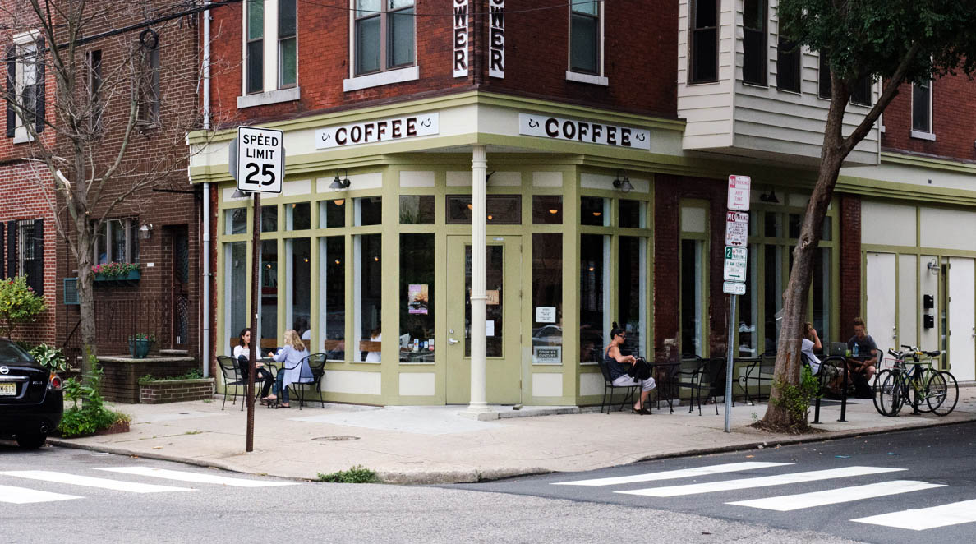
  - DESCRIBE the place of Cultural Landscape #1.
  - DESCRIBE the place of Cultural Landscape #2.
  - EXPLAIN the advantages to businesses in creating Cultural Landscape #1.
  - DESCRIBE (using a different example) a negative social impact of Cultural Landscape #1.

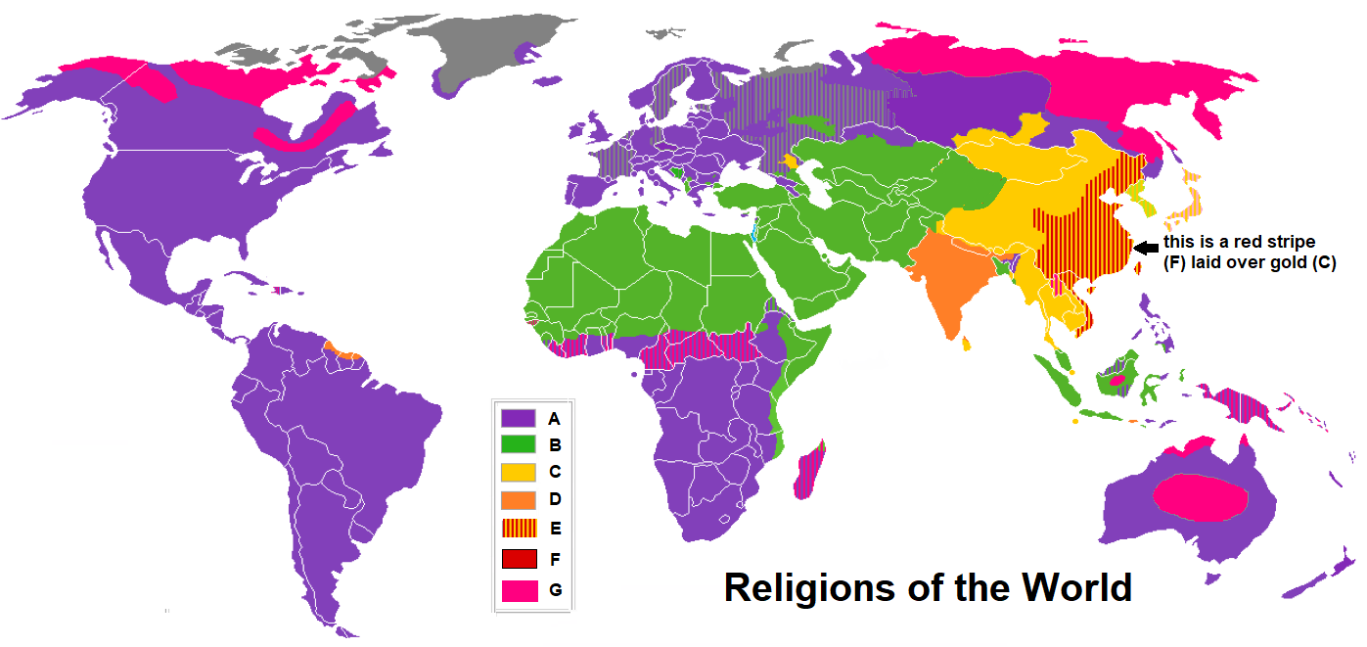
- Using APHG terms and concepts, answer the following questions referring to the map below.

  - IDENTIFY religions A, B, C, and D.
  - Using APHG terms, EXPLAIN the distribution of religion B.
  - Using APHG terms, EXPLAIN the distribution of religion D.
  - Using APHG terms, DESCRIBE the diffusion of religion A.
  - DESCRIBE two effects on the landscape of religion B.
  - IDENTIFY the religions represented by F.
  - DEFINE the APHG religious concept that is reflected by the color coding on E.
  - DESCRIBE a different example of the concept identified above (prompt g).
  - IDENTIFY the religious practice practiced in G.
  - DESCRIBE a weakness with how the distribution of religion is displayed on the map above.
  - DESCRIBE a second weakness with how the distribution is displayed on the map above.

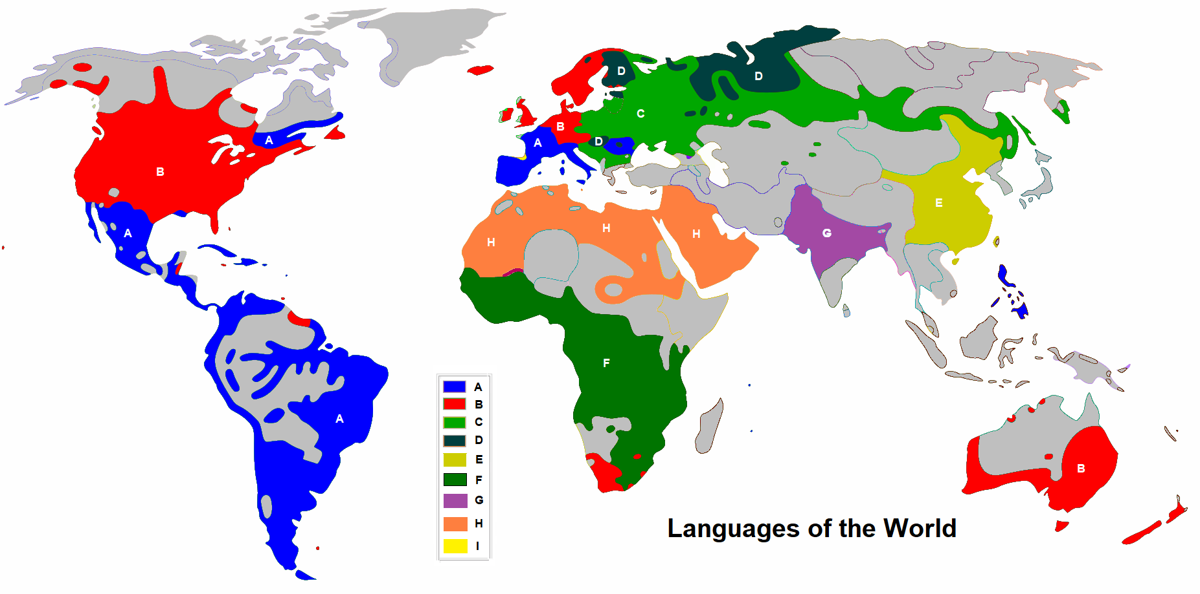
- Using AP terms and concepts answer the following questions with regards to the distribution of language families and branches. This map has been simplified and much of the detail has been eliminated by graying out areas. Your answers should concentrate on the areas that are color coded. The letters on the map are there to assist you in matching the distribution to the color in the key.

  - IDENTIFY the language family AND specific branches represented by A, B, C and G.
  - IDENTIFY the language families represented by D, E, F and H.
  - DESCRIBE the common reason for the distribution of language families A & B.
  - EXPLAIN the cultural factor linked to distribution of language family H.

  - DESCRIBE an example of an isogloss from the map above.

  - DESCRIBE two examples of isoglosses that serve as a centrifugal forces WITHIN states.

- Jerusalem is the site of many culturally significant places. Religion has shaped the cultural landscape of this area.
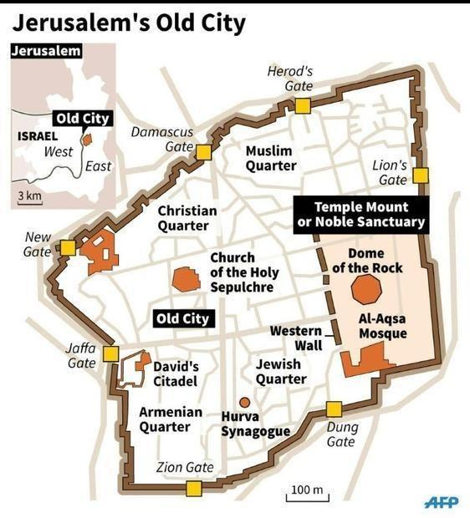

  - Citing specific examples from the map above, EXPLAIN the role of sequent occupance in the formation of Jerusalem’s cultural landscape.

  - EXPLAIN how Jerusalem represents an interfaith boundary.
________________________below does not specifically refer to the map above_________________________
  - DESCRIBE an example of an interfaith boundary in Africa.
  - DESCRIBE an example of intrafaith boundary in the Middle East/Southwest Asia.
  - DESCRIBE an interfaith boundary in Europe.
  - DESCRIBE and intrafaith boundary in Europe.

- Cultural Landscape. Analyze the photo below and answer the questions. There are some cross over concepts with Unit 4 The Geography of Identity and Politics.
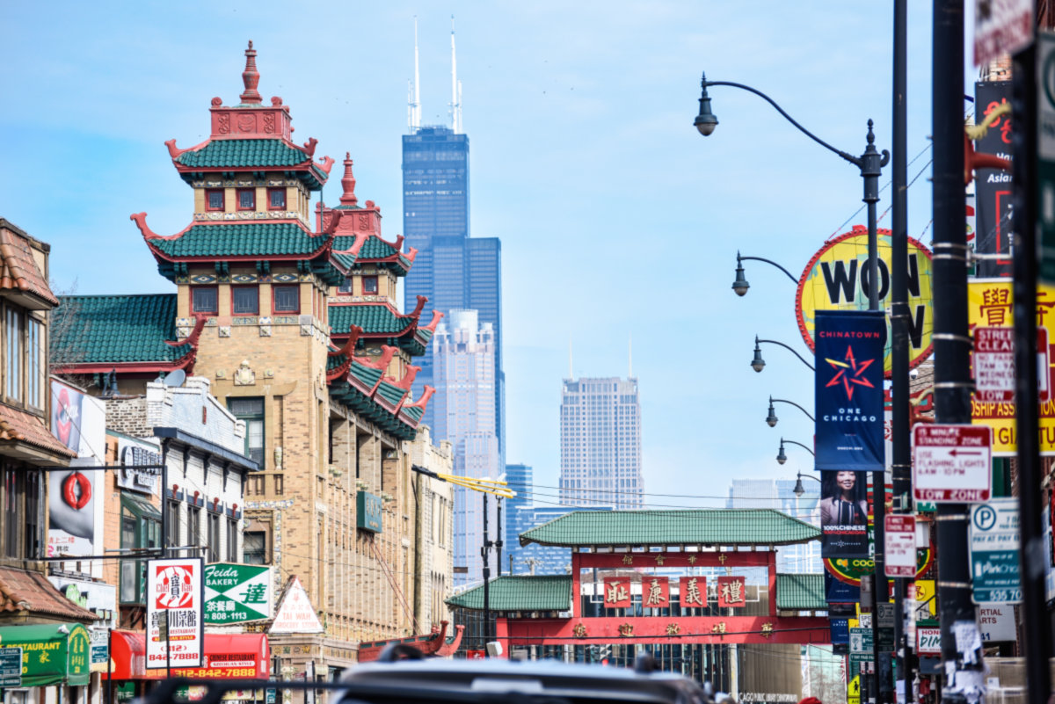
  - DEFINE the term (Unit 3) used to describe the type of culture this photo represents.
  - IDENTIFY (from Unit 4) the type of cluster represented by the photo.
  - DESCRIBE (using three examples) the predominant culture reflected in the landscape seen above (creation of “place”).
  - DESCRIBE two advantages of an urban cluster such as the one shown above.
  - EXPLAIN using APHG terms and concepts the concept of invasion and succession as it relates to urban clusters.

- Analyze the cartoons below in order to answer the following questions using APHG terms and concepts.
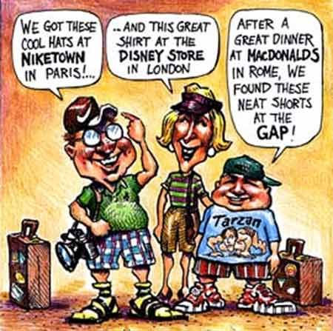
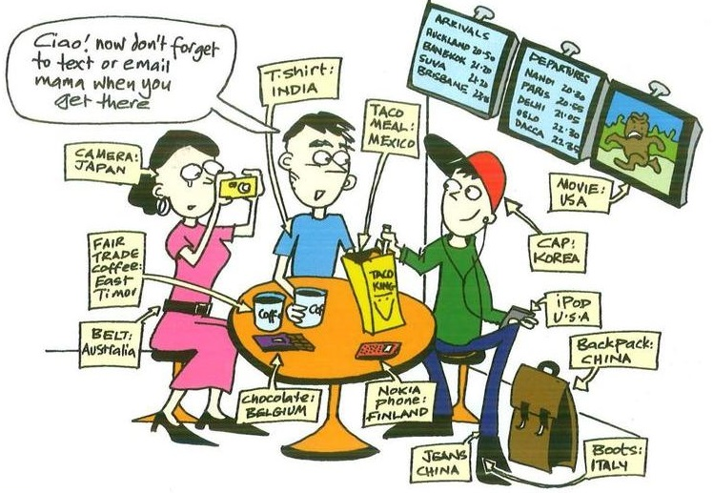

  - IDENTIFY the process reflected in the cartoons.
  - DESCRIBE two negative impacts of the process reflected in the cartoons.
  - DESCRIBE a positive impact of the process reflected in the cartoons.
  - EXPLAIN a reaction to the process reflected in the cartoon in the Islamic world.
  - COMPARE the concepts of cultural relativism and ethnocentrism.

