AP Human Geography Unit 2b Migration Review Mr. Stepek
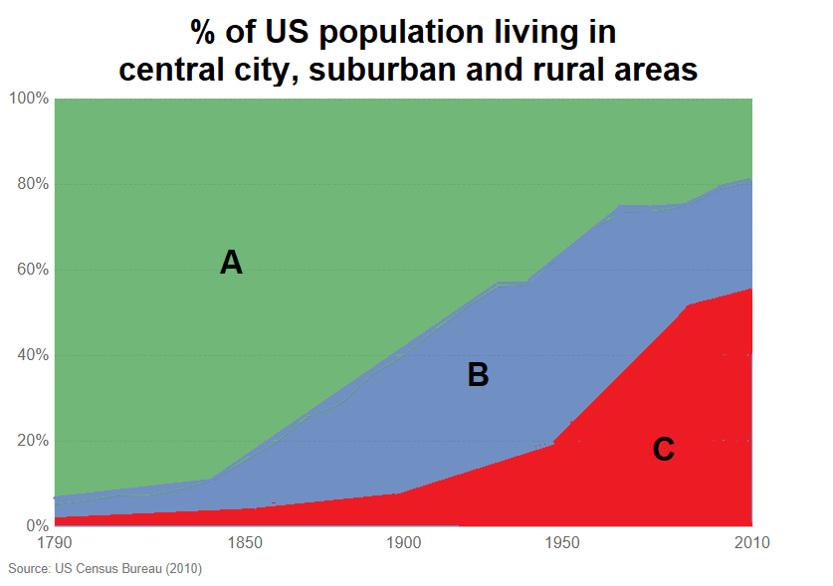
- Examine the graph below which represents the percentage of the American populaiton lviing in different environments over time.

  - IDENTIFY the environment (central city, suburban or rural) represented by each A, B and C.
  - IDENTIFY the APHG term that is represented by the interregional migration between areas A and B between the years 1850 and 1950.
  - DESCRIBE a pull factor that accounts for the interregional migration between areas A and B between the years
1850 and 1950.
  - DESCRIBE a push factor that accounts for the interregional migration between areas A and B between the years 1850 and 1950.
  - IDENTIFY the APHG term that is represented by the intraregional migration between areas B and C after the year 1950.
  - DESCRIBE a pull factor that accounts for the intraregional migration between areas B and C after the year 1950.
  - DESCRIBE a push factor that accounts for the intraregional migration between areas B and C after the year 1950.
  - EXPLAIN a socioeconomic effect on area B of the intraregional migration between areas B and C after the year 1950.

- Examine the following map regarding reapportionment. In order to answer the following questions you will have to incorporate learning form Unit 4 as well.
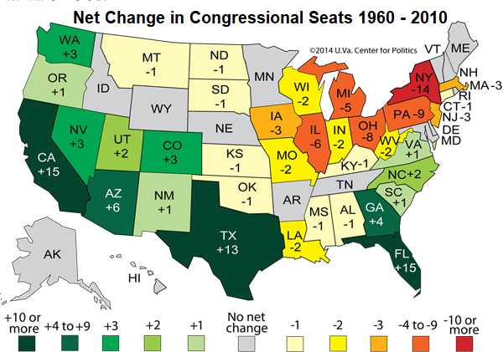

  - EXPLAIN the process of reapportionment.
  - IDENTIFY an interregional migration that would have resulted in the reapportionment reflected in the map above.
  - DESCRIBE an environmental pull factor that would have resulted in the interregional migration identified under part b.
  - EXPLAIN an economic push factor that would have resulted in the interregional migration identified under part b.

- Examine the map below reflecting the change in the center of U.S. population from 1790 to 2010.
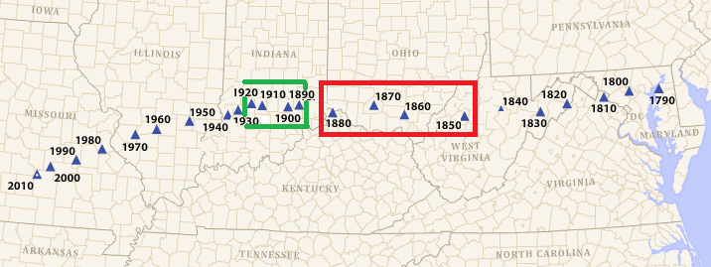
  - COMPARE the change in the center of U.S. population between the 30-year periods from 1850 to 1880 (red box) and the 30-year period from 1890 to 1920 (green box).
  - DESCRIBE one economic pull factor that would explain the change in the center of U.S. population from 1850 to 1880.
  - EXPLAIN the magnitude of the change in the center of U.S. population from 1890 to 1920.
- Examine the global map of net-migration over the last two decades. Answers to the questions below will have cross over application to both Unit 3 Cultural Geography and Unit 4 Political Geography.
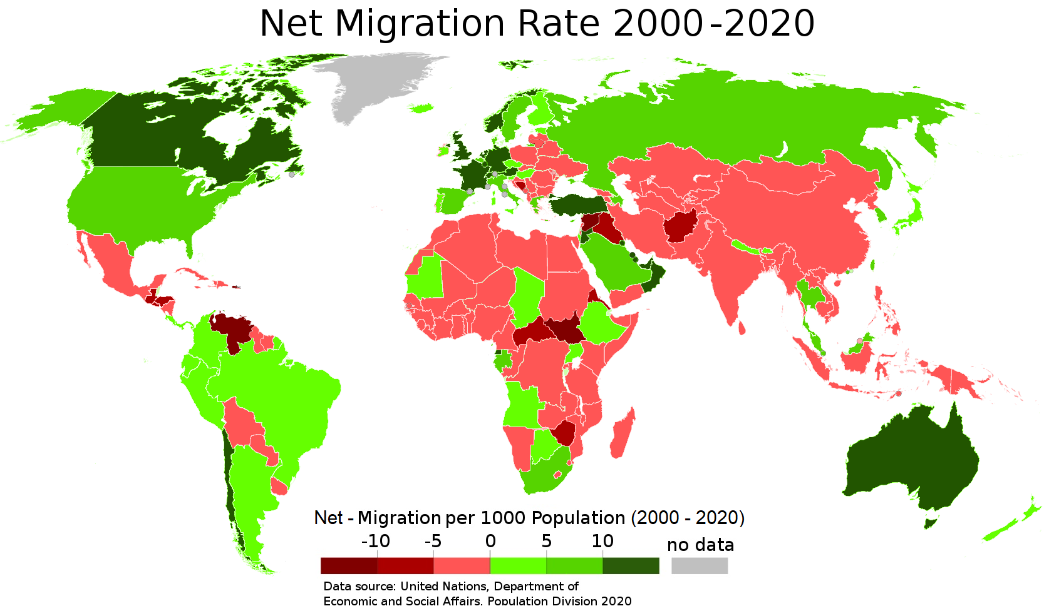
  - EXPLAIN the global pattern of net-migration using Zelinsky’s Migration Transition Model.
  - DESCRIBE a common political push factor in many countries with very high (> -5) out-migration rates using two examples from the map.
  - EXPLAIN an economic push factor for the net migration pattern within Europe between 2000 and 2020.
  - EXPLAIN a political reason for Europe’s migration pattern in years between 2000 – 2020.
  - EXPLAIN a cultural/social impact on Western Europe of net in-migration.
  - IDENTIFY the reason why the Persian Gulf States have net in-migration.

- The bar graph below refers to immigration streams into the United States.

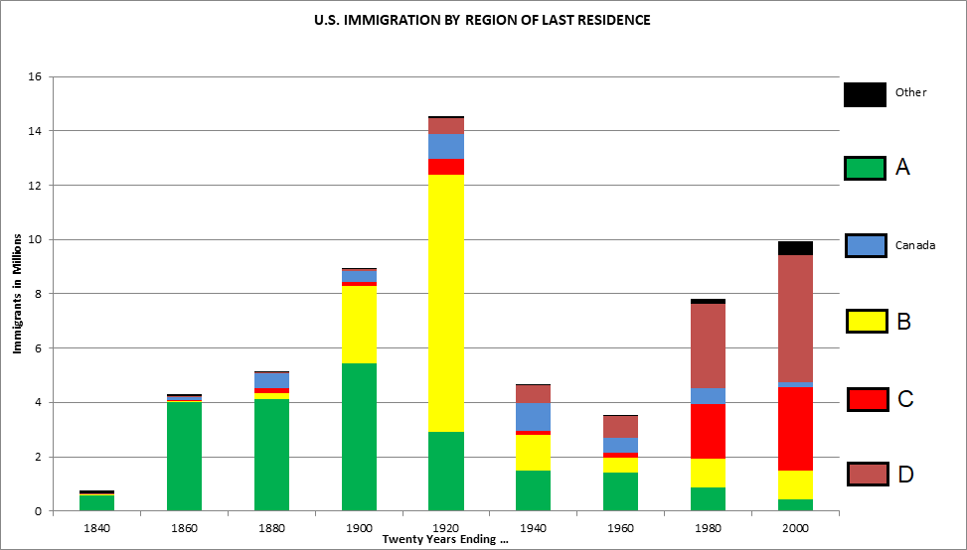

  - IDENTIFY the global region(s) represented for each migration stream A, B, C and D.
  - DESCRIBE an environmental push factor for migration stream A.
  - EXPLAIN an economic push factor common for migration streams B, C and D.
  - DESCRIBE a specific non-economic push factor for migration stream B.
  - IDENTIFY an economic pull factor for migration stream B.
  - DESCRIBE a political reason for the uptick in immigration in years after 1960.
  - DEFINE four ways an immigrant can gain legal entrance into the United States.

