AP Human Geography Unit 2 Population Review Mr. Stepek
Directions: Please use the sources to answer the questions to the level of prompt indicated.
  - Answer the following questions using Sources X and Y, and your knowledge of the demographic transition model:
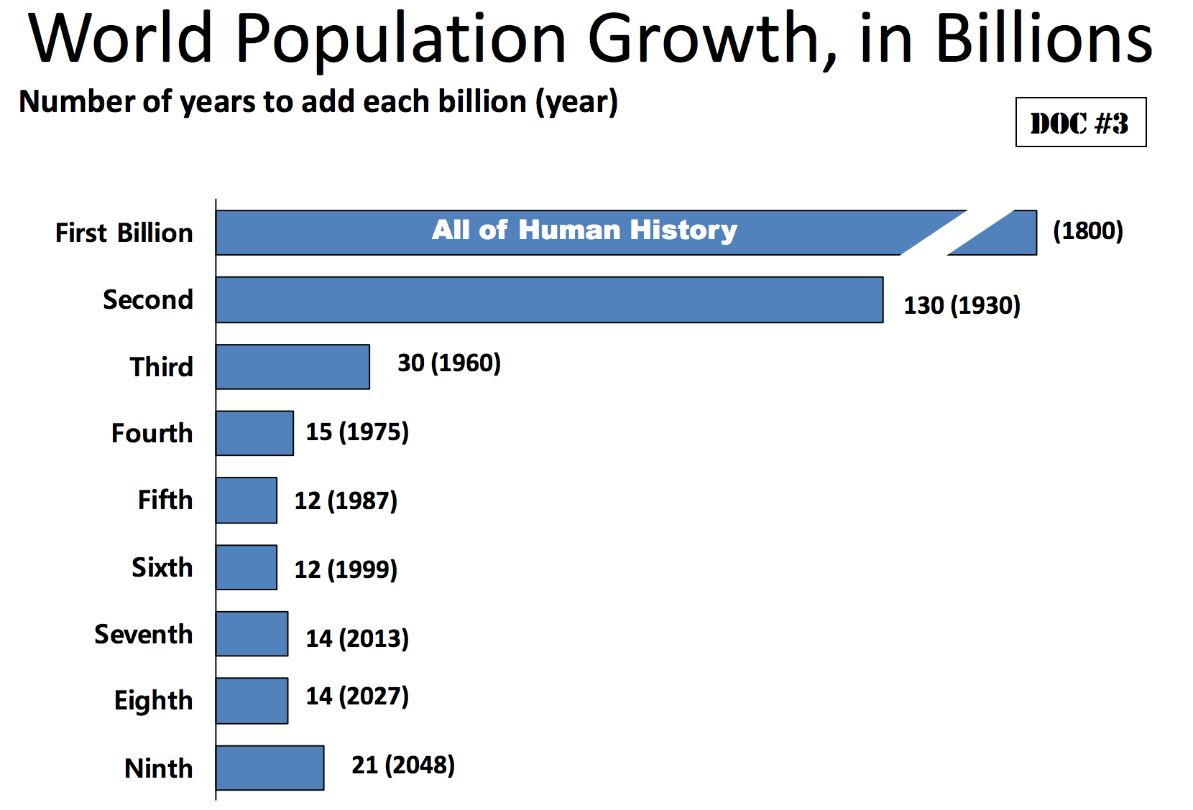
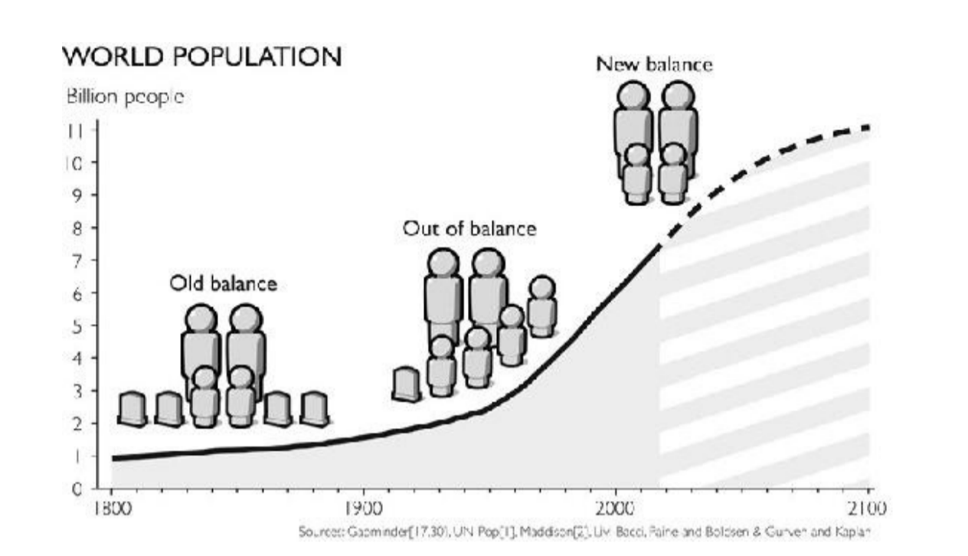
Source X: Source Y:

- According to Source X, IDENTIFY the year in which world population reached one billion.
- EXPLAIN why it only took 130 years for global population to reach 2 billion?
- EXPLAIN the main reason why global population doubled between 1930 and 1975?
- Looking at Source Y, EXPLAIN what is meant by the graphic labelled “Old Balance”.
- Looking at Source Y, EXPLAIN what is meant by the graphic labelled “New Balance”.
- Looking at Source Y, EXPLAIN why world population continues to rise despite the “New Balance”.
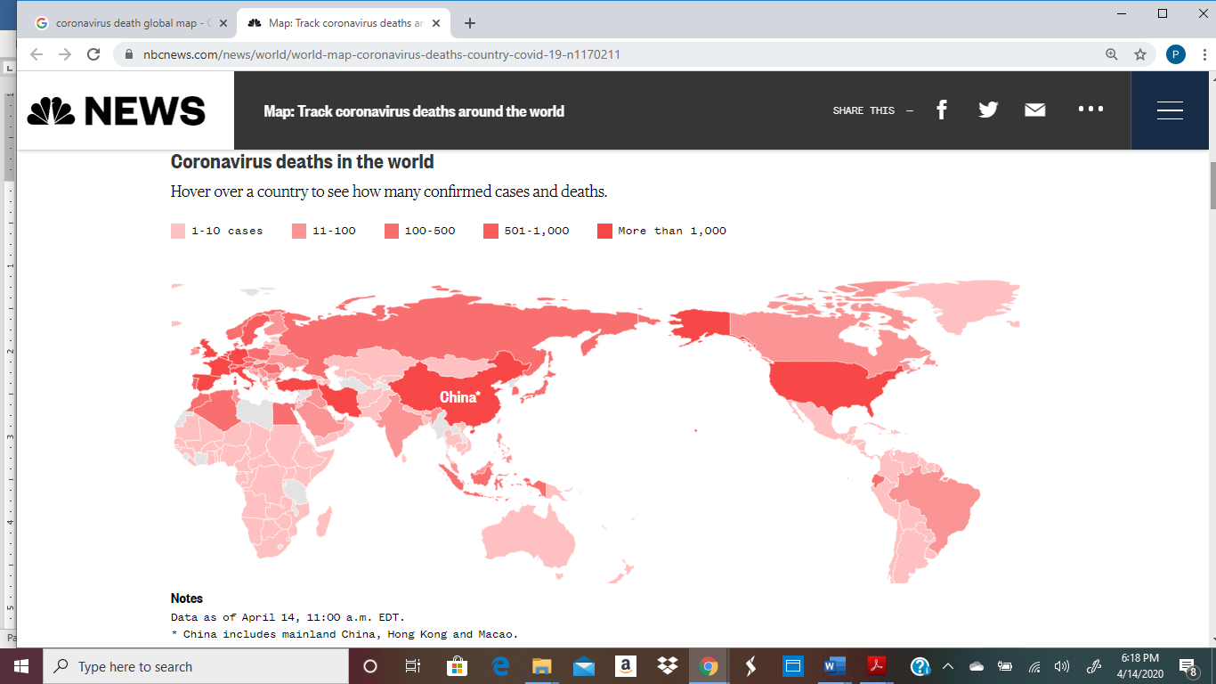
  - Answer the following question using map below and your knowledge of the epidemiological transition:
.
- EXPLAIN two reasons how the distribution of deaths from COVID-19 as shown on the map above reflects the epidemiological transition model.
- DESCRIBE an example from the map above on how the distribution of deaths form COVID-19 does not fit the epidemiological transition model.
- Answer the following questions using the chart below and your knowledge of the demographic transition model:
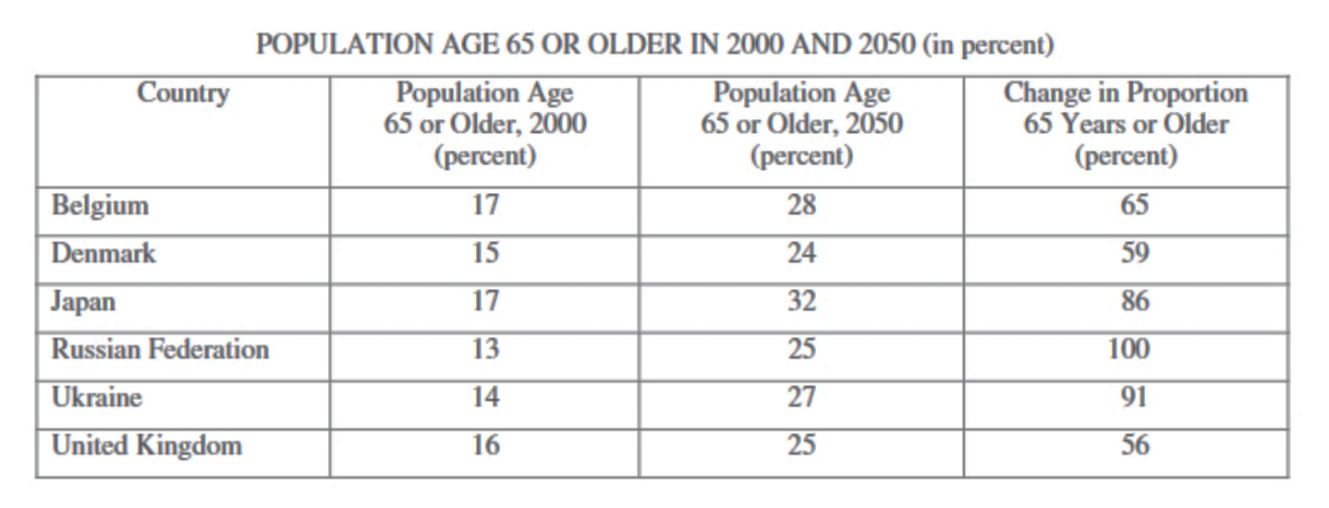
- IDENTIFY the common trend in population dynamics for the selected countries listed.
- EXPLAIN the economic impact of this trend on those societies.
- DESCRIBE a strategy that could be used to counteract this trend.
- DESCRIBE a different strategy (than the one used under C) that could also be used to counteract this impact.
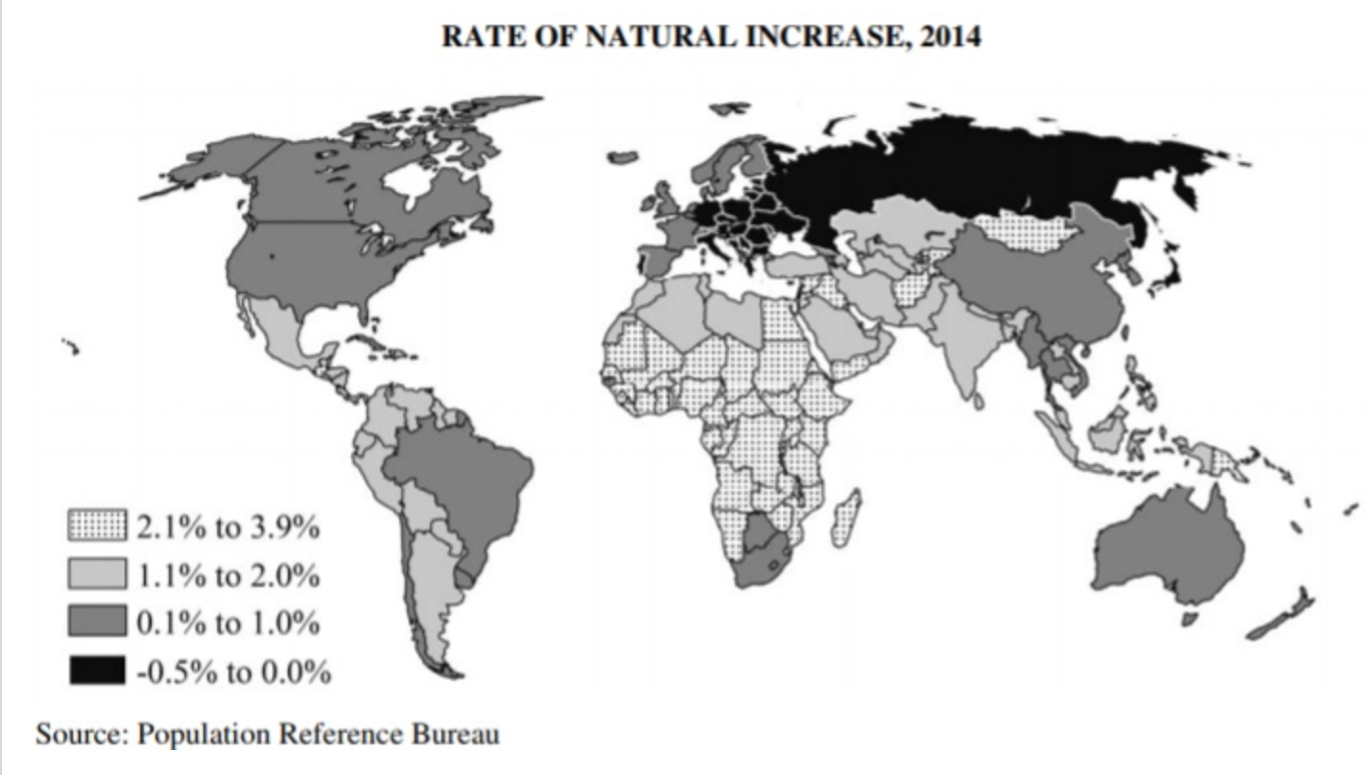
- Answer the following questions using the map below and your knowledge of the demographic transition model:

- IDENTIFY the world region on the map with the highest rates of natural increase.
- IDENTIFY and EXPLAIN the negative cycle that many of these countries may be caught in.
- EXPLAIN a social factor that would be most effective in breaking the cycle of high birth rates.

- Answer the following questions using the graphs below and your knowledge of the Malthusian theory.

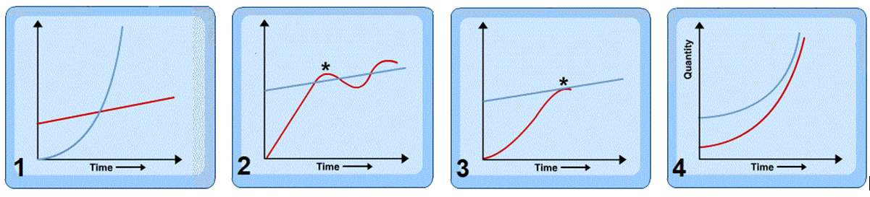
- Utilizing graph #1, DESCRIBE Malthusian Population Theory.
- According to Malthus, DESCRIBE what is represented at the star in graph #2.
- In graph #3, DESCRIBE a government strategy (as represented by the star) that may have been employed.
- DESCRIBE the population theory represented by graph #4.
- EXPLAIN a criticism that a neo-Malthusian would have of graph #4.

- Answer the following questions using the population pyramids and your knowledge of the demographic transition.

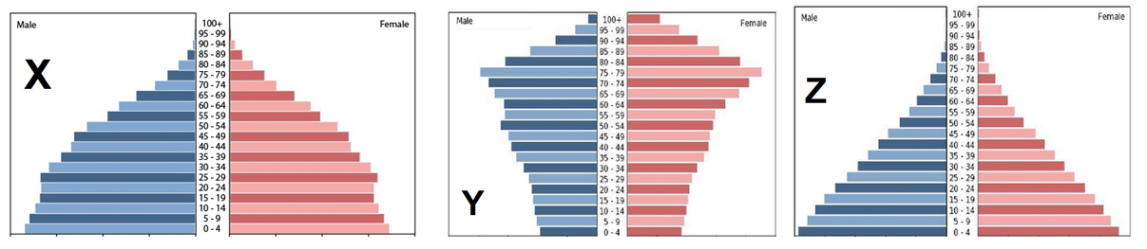

- IDENTIFY the stages of the demographic transition represented by pyramids X, Y and Z.
- For pyramid X, EXPLAIN how this population structure was created.
- For pyramid Z, EXPLAIN how this population structure was created.
- For pyramid Y, describe two distinct socioeconomic problems that arise from this population structure.

