AP Human Geography Unit 1 Basic Concepts and Development Review Mr. Stepek
1. Theories of Cultural Ecology
Man is a product of the earth's surface. This means not merely that he is a child of the earth, dust of her dust; but that the earth has mothered him, fed him, set him tasks, directed his thoughts, confronted him with difficulties that have strengthened his body and sharpened his wits…She has entered into his bone and tissue, into his mind and soul. On the mountains she has given him leg muscles of iron to climb the slope; along the coast she has left these weak and flabby, but given him instead vigorous development of chest and arm to handle his paddle or oar. In the river valley she attaches him to the fertile soil, circumscribes his ideas and ambitions by a dull round of calm, exacting duties, narrows his outlook to the cramped horizon of his farm. Up on the wind-swept plateaus, in the boundless stretch of the grasslands and the waterless tracts of the desert, where he roams with his flocks from pasture to pasture and oasis to oasis, where life knows much hardship but escapes the grind of drudgery, where the watching of grazing herd gives him leisure for contemplation, and the wide-ranging life a big horizon, his ideas take on a certain gigantic simplicity; religion becomes monotheism, God becomes one, unrivalled like the sand of the desert and the grass of the steppe, stretching on and on without break or change. Chewing over and over the cud of his simple belief as the one food of his unfed mind, his faith becomes fanaticism; his big spatial ideas, born of that ceaseless regular wandering, outgrow the land that bred them and bear their legitimate fruit in wide imperial conquests…Man can no more be scientifically studied apart from the ground which he tills, or the lands over which he travels, or the seas over which he trades, than polar bear or desert cactus can be understood apart from its habitat.
Ellen Churchill Semple, January 1911

A region is a reservoir of energy whose origin lies in nature but whose development depends upon man. It is man, who, by molding the land to his own purposes, brings out its individuality. He establishes a connection between its special features. He substitutes for the incoherent effect of local circumstances a systematic concourse of forces. It is thus that a region defines and differentiates itself and becomes as it were a medal struck off in the effigy of a people.
Paul Vidal de la Blache, 1903

- IDENTIFY and DEFINE in your own words the cultural ecology theory reflected in the first passage.
- IDENTIFY and DEFINE in your own words the cultural ecology theory reflected in the second passage.
- EXPLAIN why the viewpoint expressed in the first passage has fallen out of favor.
- EXPLAIN an example in the contemporary world of the theory expressed in the second passage.

- Using Chicago as an example, demonstrate your understanding of the Five Themes of Geography (be complete this should include “Location”, “Place”, “Region”, “Interaction” and “Movement” including subcategories).

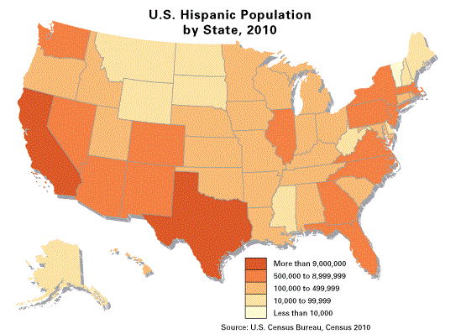
- Answer the following questions based on the maps below:
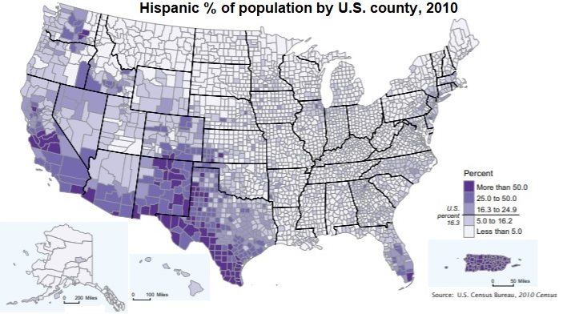

- IDENTIFY the type of thematic map represented above.
- IDENTIFY one strength of presenting data in this type of thematic map.
- Provide two EXPLANATIONS for the difference in the presentation of the spatial distribution of the Hispanic population in the United States despite the fact that both maps use a common data source of the 2010 US Census.
- Using APHG concepts, EXPLAIN two reasons for the spatial distribution of Hispanics within the United States.

- Other Thematic Maps
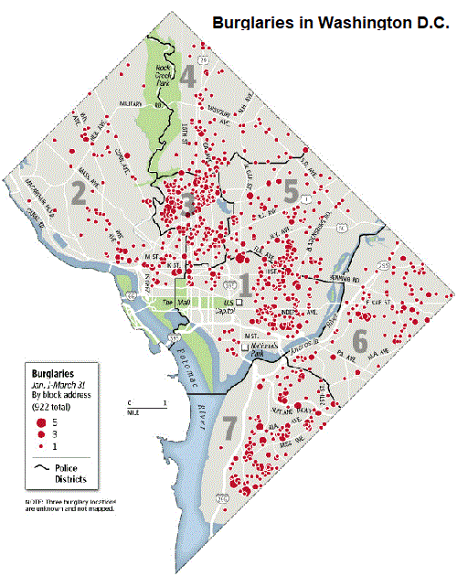

a. IDENTIFY the type of thematic map displayed to the left.
b. DESCRIBE one advantage to the user of how data is displayed on this type of thematic map.

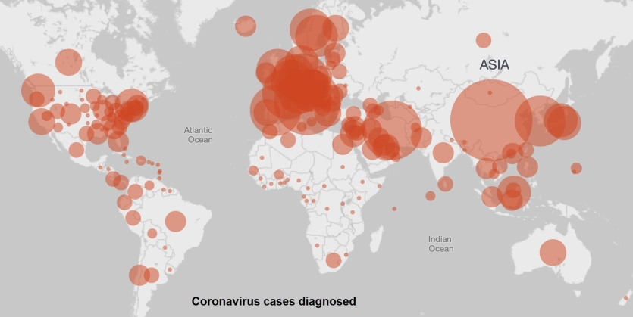
c. IDENTIFY the type of thematic map displayed to the left.
d. DESCRIBE one advantage to the user of how data is displayed on this type of thematic map.
e. DESCRIBE one disadvantage to the user of how data is displayed on this type of thematic map.

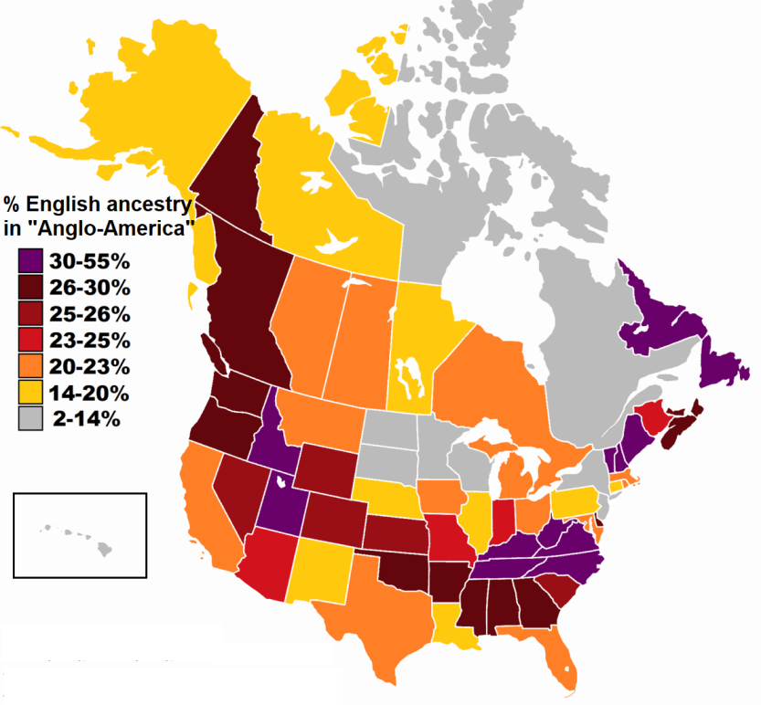

f. IDENTIFY the type of thematic map displayed to the left.
g. DECSRIBE a flaw in how data is presented in this particular example.

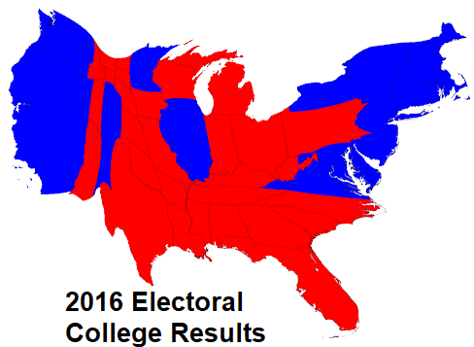

h. IDENTIFY the type of map displayed to the left.
i. DESCRIBE an advantage to the reader of presenting data as it is displayed in the map to the left.

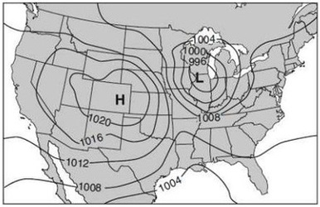
j. IDENTIFY the type of map displayed to the left.
k. DESCRIBE in general what the lines depicted on a map like the one to the left are connecting.
l. IDENTIFY for what two purposes is this type of map most commonly used?
m. IDENTIFY the term that describes a map like the one displayed to the left but with colored bands in between lines depicted.

- The Properties of Spatial Distribution
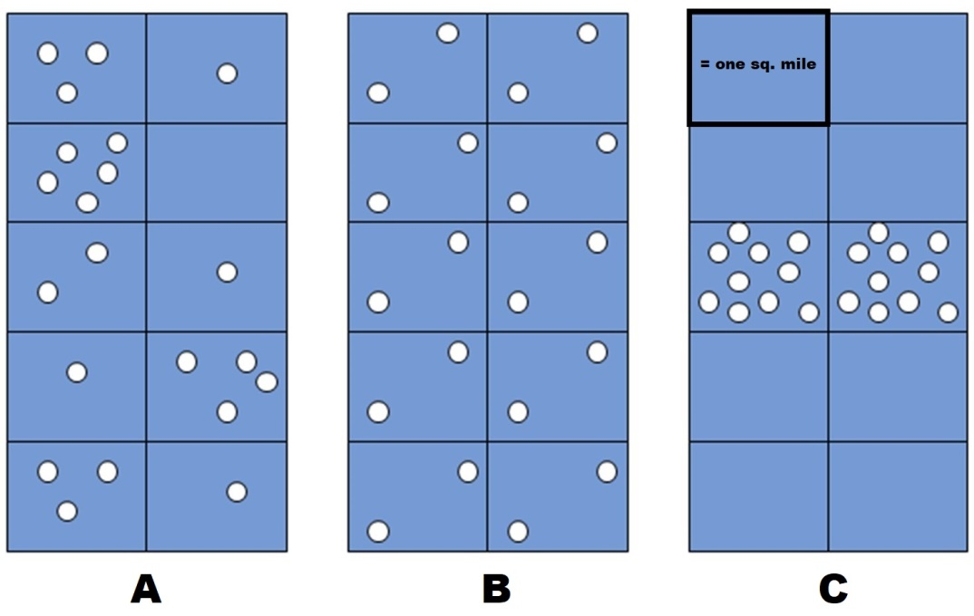
a. DEFINE spatial concentration and COMPARE the concentration between A and C.
b. DEFINE spatial pattern and COMPARE the pattern between A and B.
c. DEFINE and CALCULATE (per square mile) the arithmetic density in A and B.

- Density Measures and their Implications
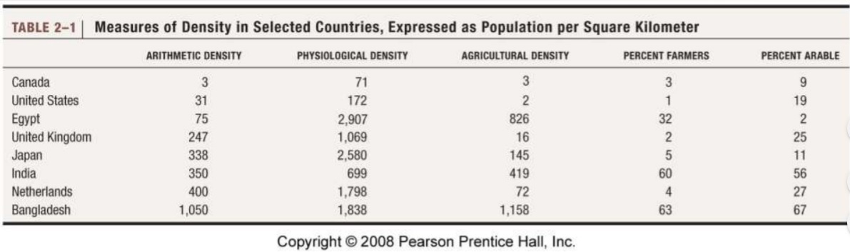

- DEFINE carrying capacity.
- EXPLAIN which country above would have the most difficult time supporting the needs of its population without trade or development.
- EXPLAIN which country above would have the least technologically advanced agricultural sector.
- COMPARE the agricultural sectors of Japan and India with regards to its ability to meet the needs of its population without trade and the efficiency of the sector.
7. Cultural Diffusion
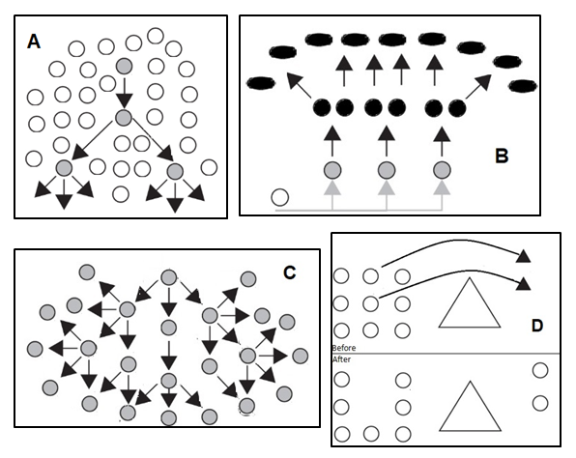

a. IDENTIFY and DESCRIBE the diffusion pattern represented by diagram A.
b. IDENTIFY and DESCRIBE the diffusion pattern represented by diagram B.
c. IDENTIFY and DESCRIBE the diffusion pattern represented by diagram C.
d. IDENTIFY and DESCRIBE the diffusion pattern represented by diagram D.

8. Measures of Development
  - DESCRIBE the factors used in the actual mathematical calculation of the Human Development Index.
  - DEFINE the five job sectors (another factor considered when discussing “development”).
  - IDENTIFY the three global tiers in Wallerstein’s World Systems Theory.
  - EXPLAIN how the five job sectors correlate with Wallerstein’s World Systems.

- Distribution of Development
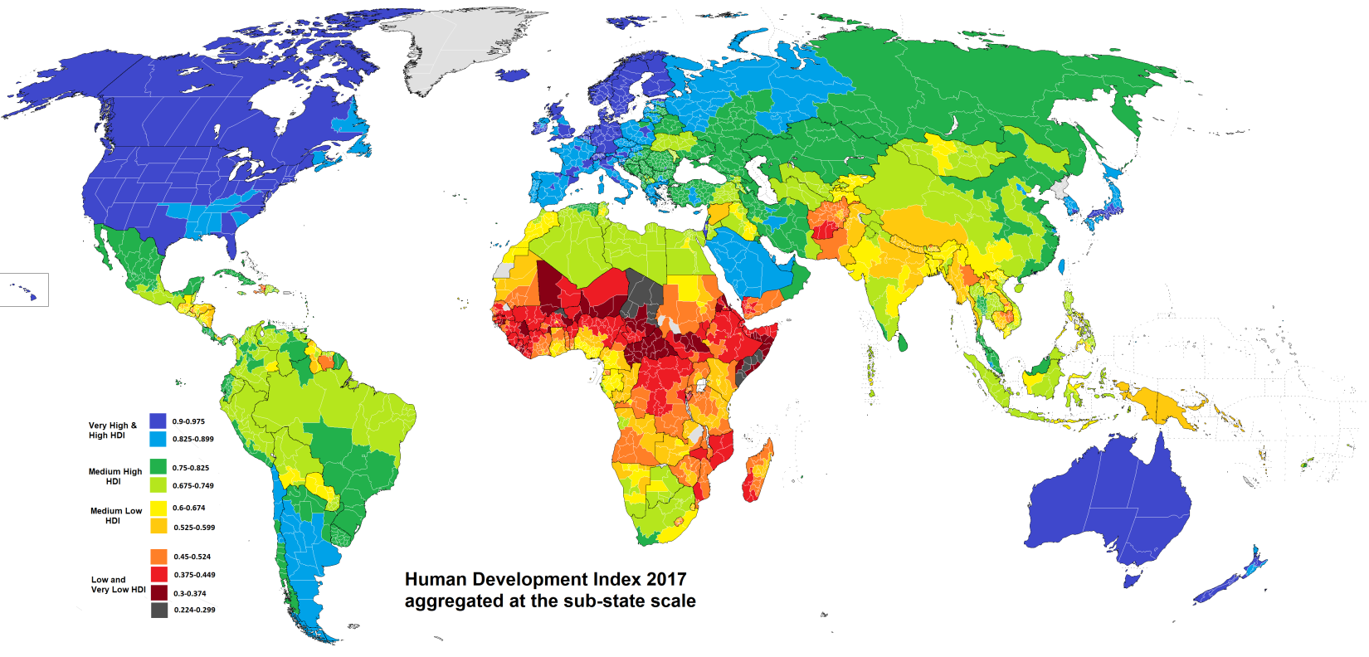

So, I found this fantastic map online which breaks down HDI by sub-state region. Refer to it in order to answer the following questions. A version you can zoom in and out of is located at this link: https://i.redd.it/46t1oery13h21.png
  - EXPLAIN an example of how the spatial distribution of development has changed since Brandt conceptualized the North-South split in the 1980s.
  - EXPLAIN how differences in development is worsening tensions in a shatterbelt region.
  - IDENTIFY a regional difference in development within the United States.
  - EXPLAIN how the sub-state development differences in China are related to the core-periphery model.

(OVER/CONTINUED)

- Distribution of Development (cross-over concepts)
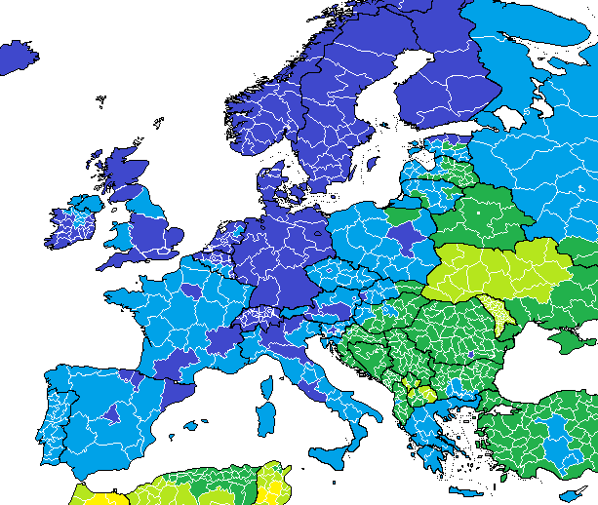
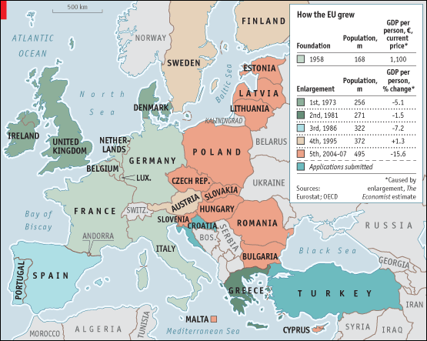

- Examine the maps above closely (you can use the zoom feature from the previous link). DESCRIBE a common feature in the distribution of development WITHIN European countries.
- EXPLAIN how differences of development in Europe have affected migration patterns with the expansion of the European Union.
- EXPLAIN two examples of how differences in development may be increasing centrifugal tensions.

