Industrial Agriculture vs. Sustainable Agriculture

Instructions: By analyzing the sources, you will learn more about industrial and sustainable agriculture, their impacts, and the reasons for/against both.

By analyzing the sources & answering the scaffolding questions, on an FRQ, you will be able to:

- Describe industrial & sustainable agriculture (using the acronym SHEEP: social/cultural, health, economic, environmental, political)

- Explain why someone would buy industrial agriculture products (using the acronym SHEEP: social/cultural, health, economic, environmental, political)

- Explain why someone would buy organic products &/or from small sustainable farms/farmers/farmers markets (using the acronym SHEEP: social/cultural, health, economic, environmental, political)

**Scroll down for scaffolding questions. Please type your responses into a separate document and upload them to Google classroom by Wednesday 4/1 at 10 pm.

Question Set 1 (Economic Factors)
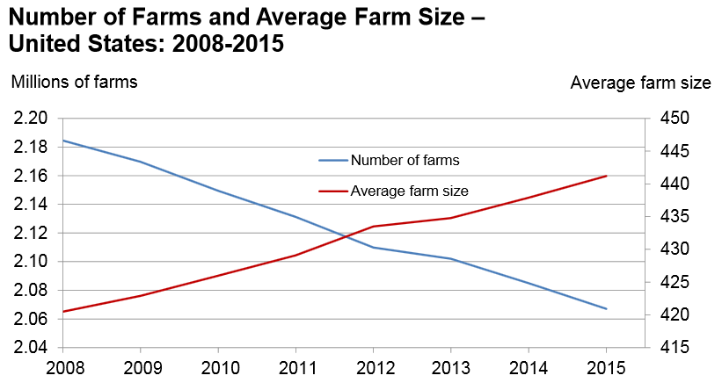
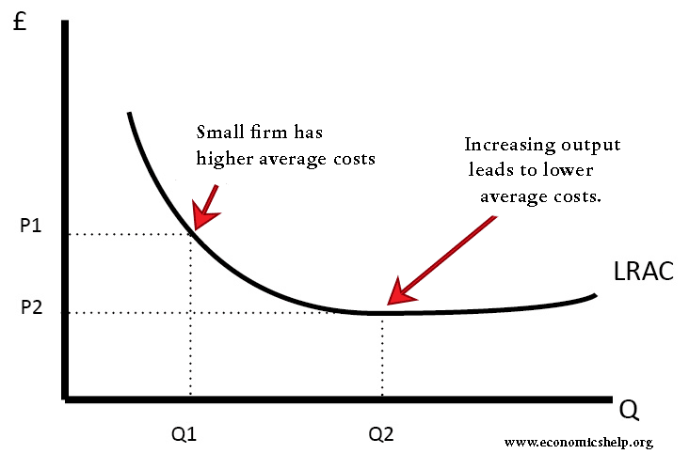

Question Set 1:
- IDENTIFY the trend in number of farms and average farm size.
- EXPLAIN an ECONOMIC reason for this trend.
- DESCRIBE an economic consequence of industrial agriculture for the American consumer.

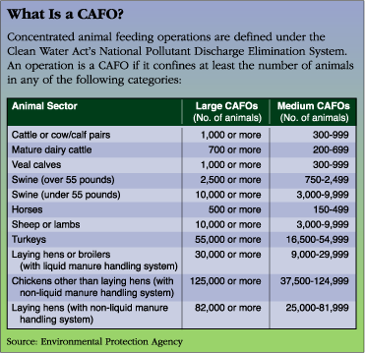
Question Set 2: Animal Welfare (Health/Political Factors)

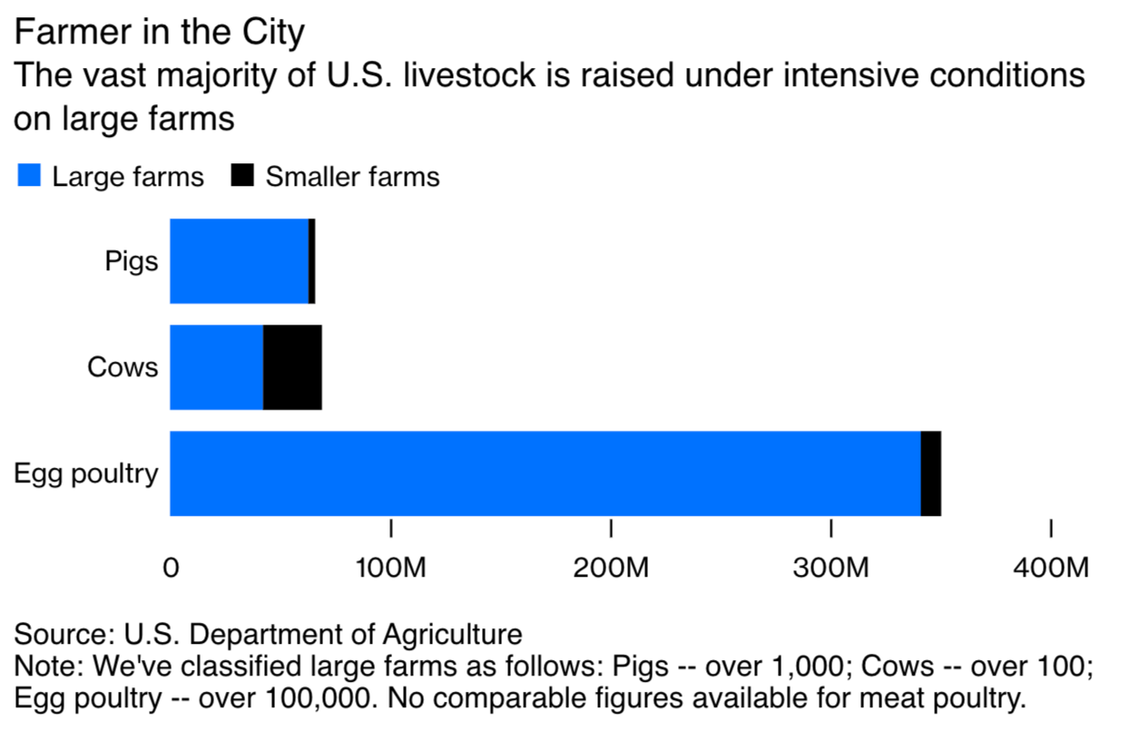

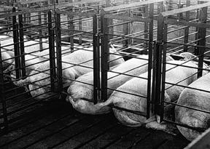 | 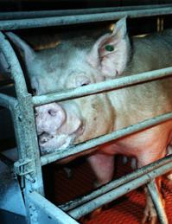
Hogs on a typical factory farm are raised in two-foot-by-seven-foot crates that allow them to lie down but not turn around. Manure is collected in pits under the cages. They are typically confined indoors from birth until they go to the slaughterhouse. (Humane Society of the United States)

Question Set 2:
- In your own words, DEFINE CAFO.
- IDENTIFY two reasons for why livestock farming has been intensified.
- DESCRIBE one impact of factory/industrial livestock farming on animal welfare.

Question Set 3 (Economic /Health /Political Factors):

The two images represent two different methods of raising livestock in the United States:

Cattle Ranch (grass fed beef)  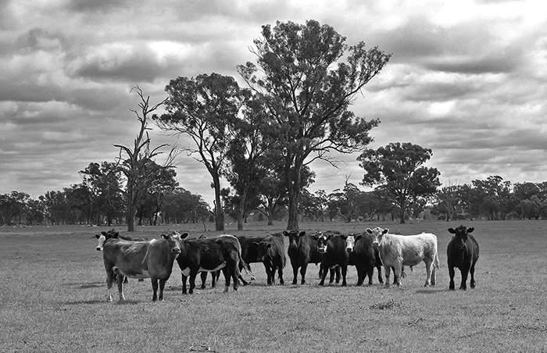 | Cattle Feedlot (corn-fed beef)  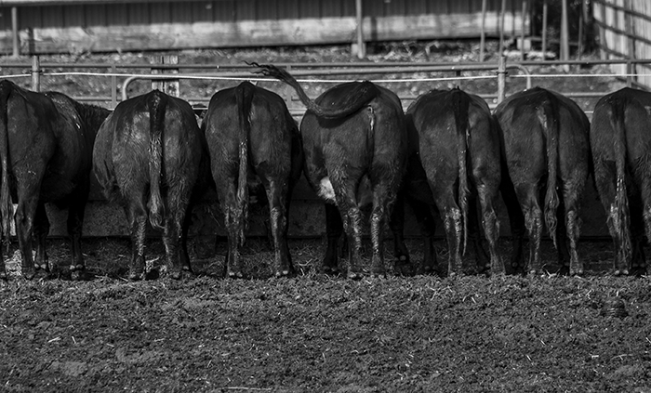
Acres of Space: 2 acres of space per cow | Acres of Space: Cows kept in small enclosed area; Appox. 1 acre of space per 100 cattle

Question Set 3:
- Based on the information above, IDENTIFY one economic reason why a consumer would buy corn-fed beef.
- Based on the information above, DESCRIBE one health reason why someone would NOT buy corn-fed beef.

Question Set 4 (Political Factors):

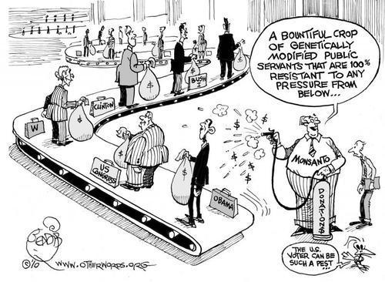
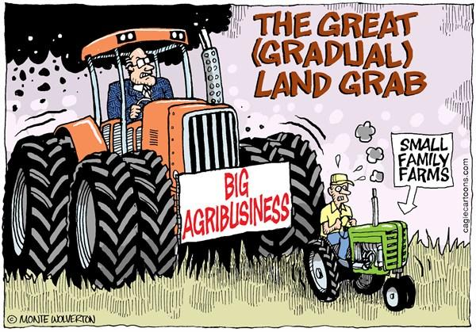

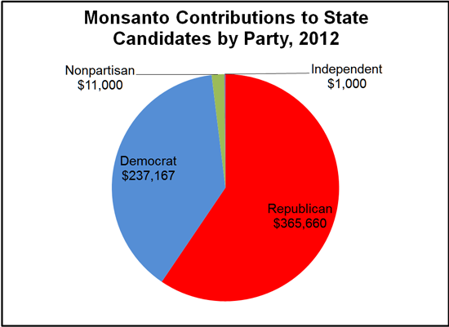
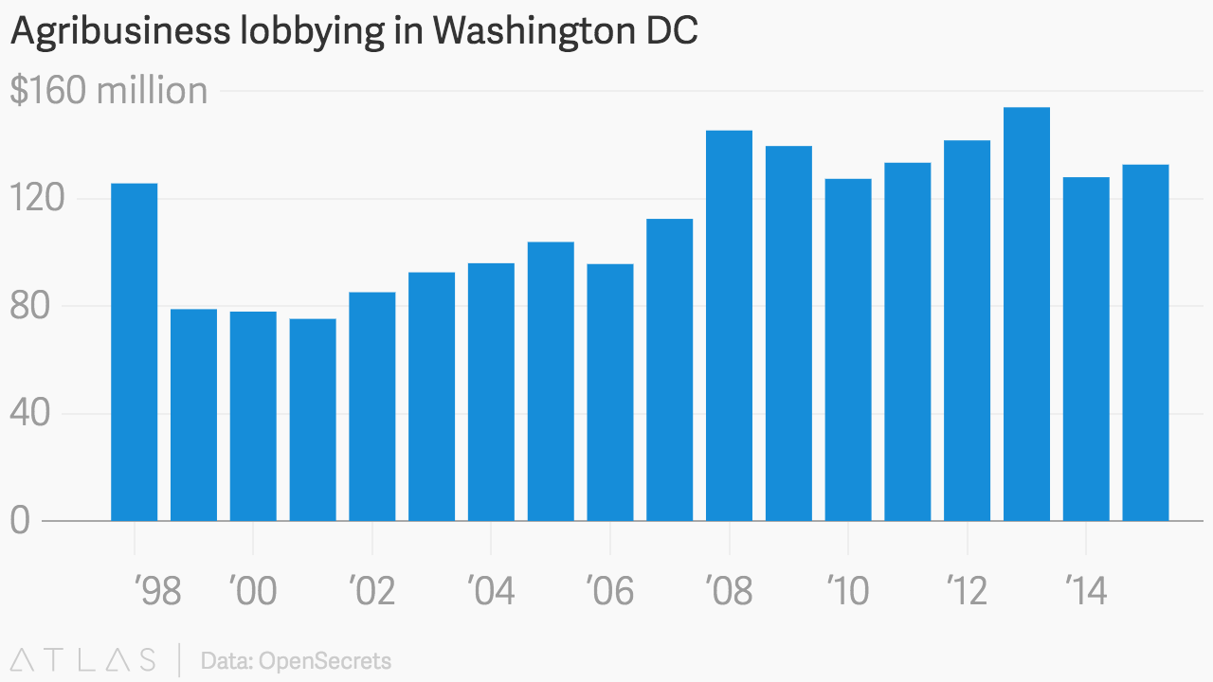

Question Set 4:
- Based on the two political cartoons, IDENTIFY two separate criticisms of agribusinesses.
- Based on the 2nd cartoon, the graph and the pie chart, DESCRIBE why agribusinesses have so much power.
- DESCRIBE one health effect of Monsanto’s political influence?

Question Set 5: (Economic Factors):

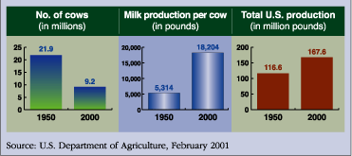

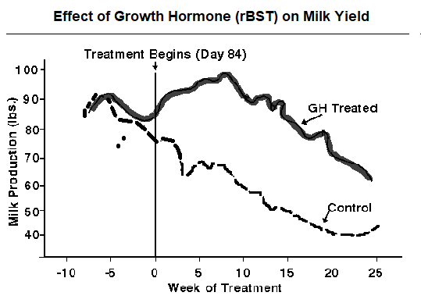

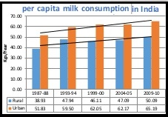

Question Set 5:
- Based on the information and graphs above, EXPLAIN one ECONOMIC impact of factory farming.
- EXPLAIN a social/economic (socioeconomic) reason for increased milk consumption in India?

Question Set 6 (Environmental/Health Factors):

Integrated Livestock Farming  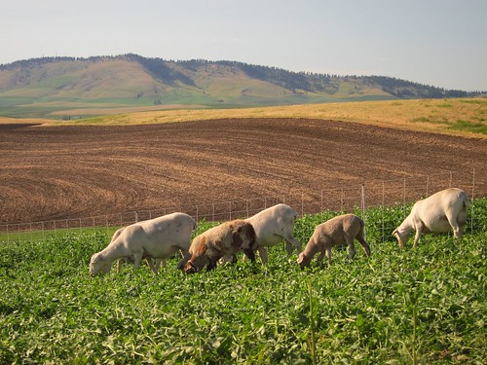 | Factory Farm  (North Carolina hog farm after a heavy rain storm)  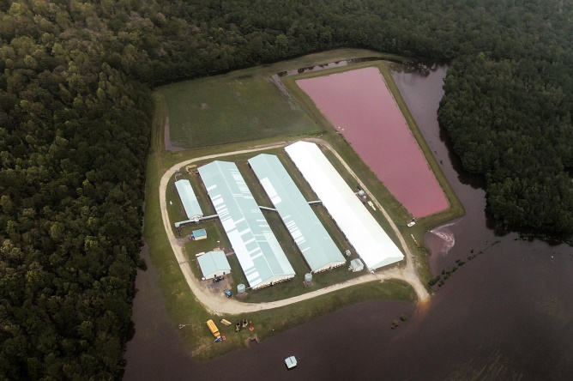

Question Set 6:
- COMPARE the land usage patterns of traditional ranching and factory farming.
- EXPLAIN the traditional benefits of animal domestication and the cultivation of crops.
- Based on the information above, IDENTIFY one environmental impact of factory farming.

Question Set 7: Community Impact

Local Community Impact of Sustainable Farming:

vs. Local Community Impact of Industrial Agriculture:

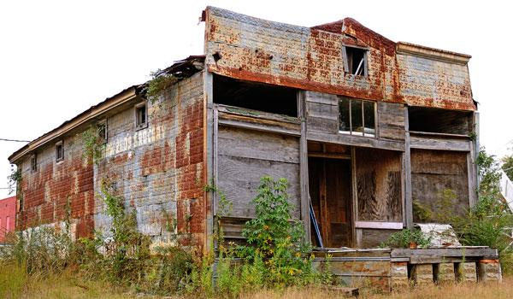

Question Set 7:
- Based on the information above, COMPARE the effects of sustainable farming and industrial agriculture on local communities.

Question Set 8: (Health Factors)

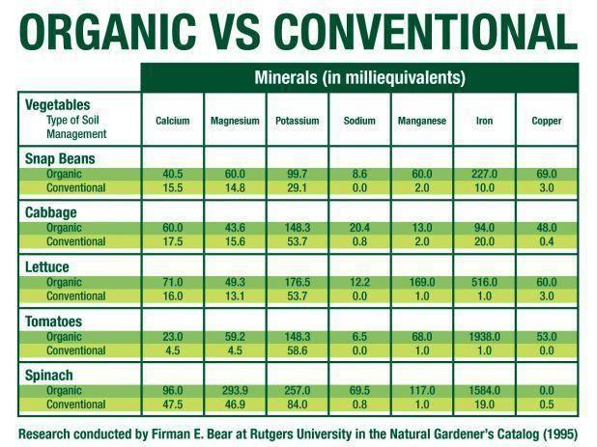

Question Set 8:
- DEFINE organic farming.
- Based on the “Organic vs. Conventional’ chart above, IDENTIFY why someone would buy organic produce over conventional produce from an industrial farm.

Question Set 9: (Health/ Economic Factors):

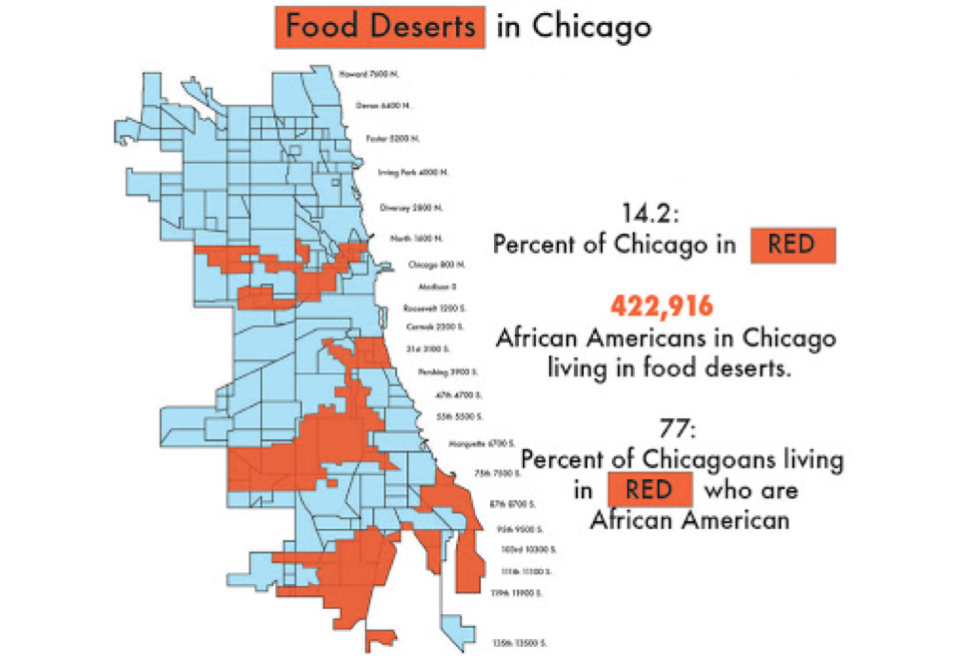

Question Set 9:
- DEFINE food desert.
- Based on the map, IDENTIFY the reason why someone living in a food desert would NOT buy organic food.
- EXPLAIN one specific potential health impact of living in a food desert.

Question Set 10: (Health/ Economic Factors):
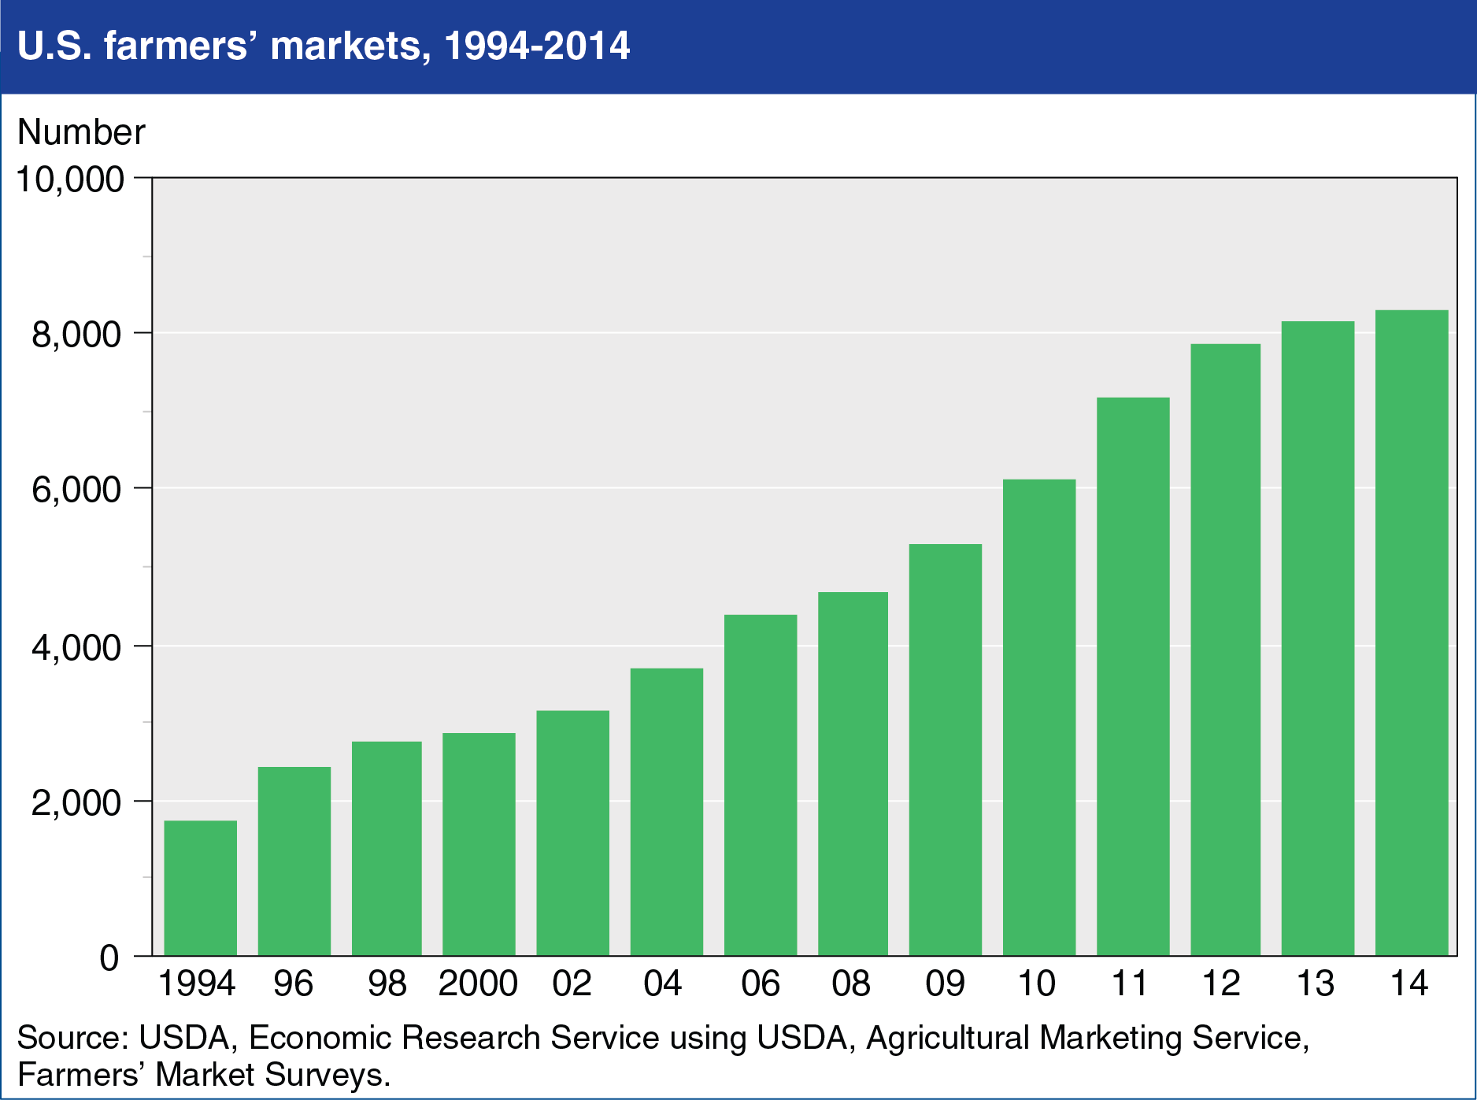

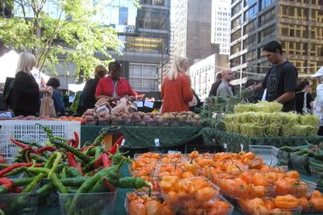

Chicago Farmers Markets:
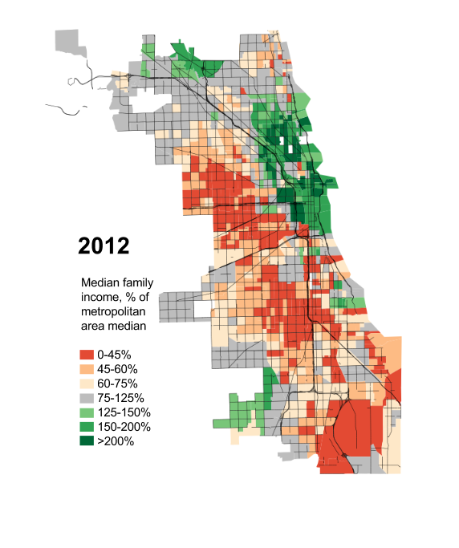

= Location of Farmers Market

Question Set 10:
- EXPLAIN one environmental reason consumers may buy from farmers’ markets?
- EXPLAIN a health or social reason (not previously used in this assignment) why people may opt to buy from farmers’ markets.
- Based on the maps of Chicago, IDENTIFY and EXPLAIN the correlation between the location of farmer’s markets and per capital income.

Question Set 11: (Animal Welfare/ Health Factors)

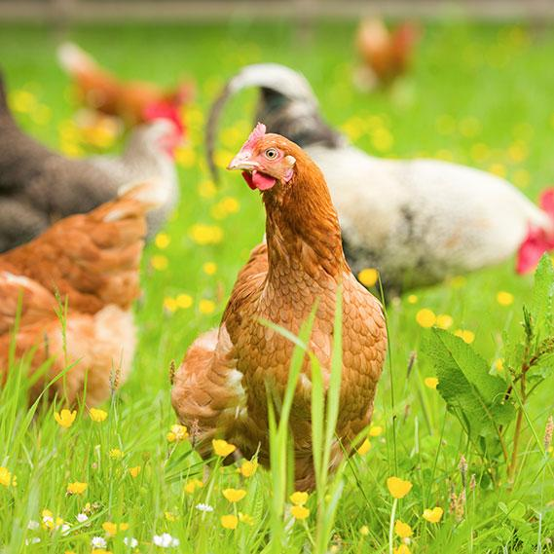 | 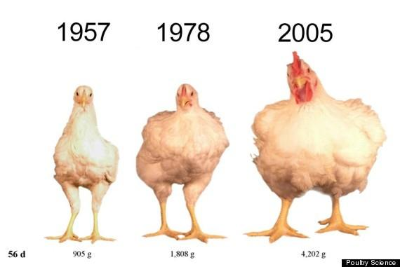  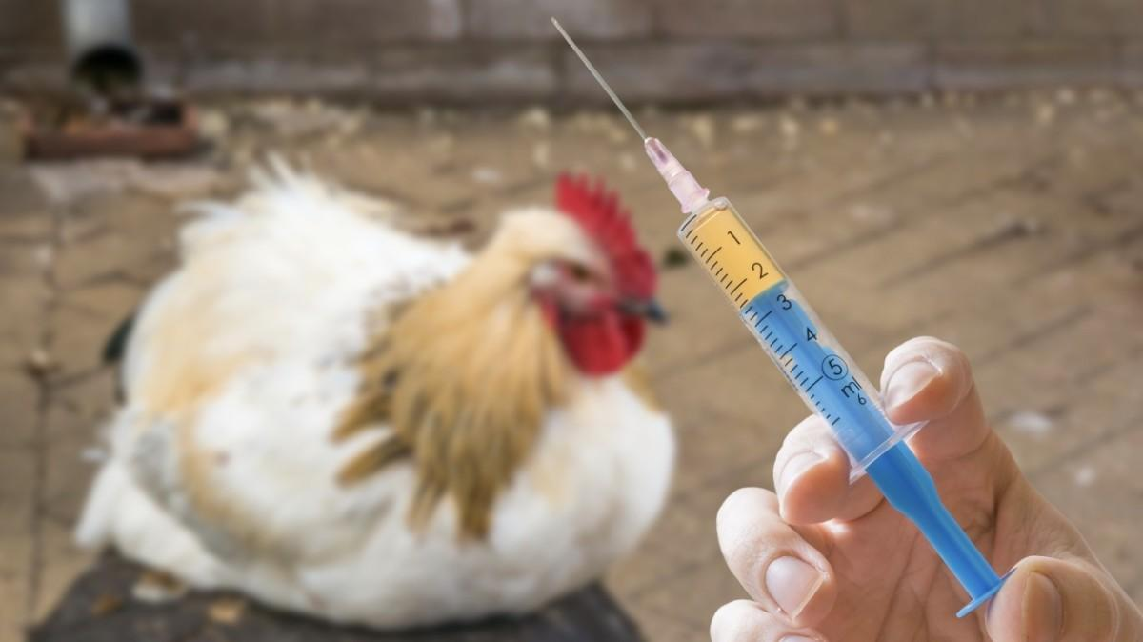
Free Range Chicken from a Sustainable Farm  "Free-range" is a term that refers to a method of animal husbandry where animals are able to roam freely outdoors | Industrial “Factory Farm” Chicken

Question Set 11:
- COMPARE how free range chicken from sustainable farms are raised versus how chicken from industrial farms are raised.
- DECSRIBE on animal welfare issue that may keep consumers from buying factory farmed chicken.
- Based on the information above, DESCRIBE one health effect of buying factory farm-raised chicken.
- EXPLAIN why fast food and other restaurants (ie. KFC, McDonalds) buy chicken from factory farms.

Question Set 12: (Environmental Factors)

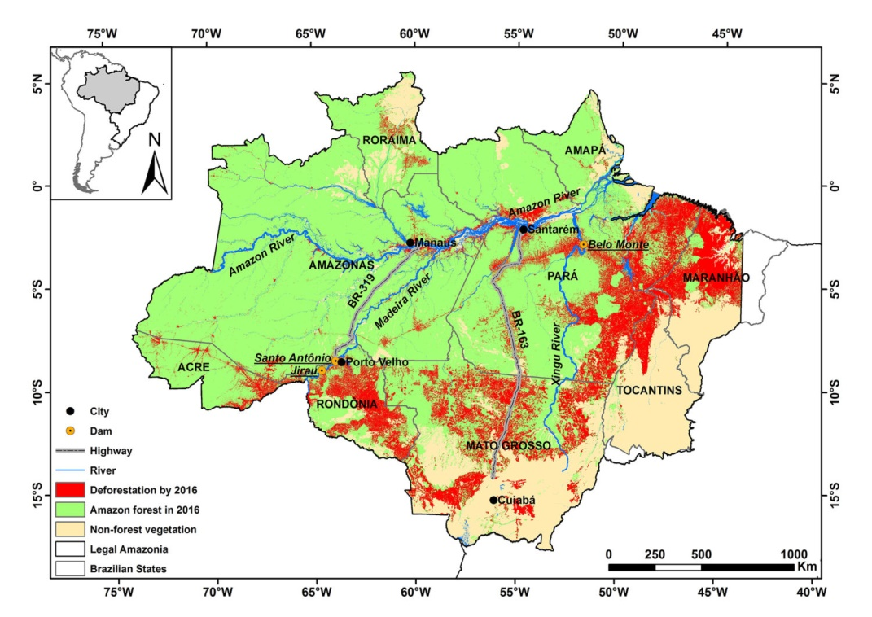
Question Set 12:

- DESCRIBE how agriculture was traditionally practiced in the above region?
- IDENTIFY the main reason for deforestation in the region above.
- EXPLAIN how that reason for deforestation fits into Wallerstein’s World Systems theory.

