AP Human Geography Calculating and Understanding Dependency Ratios Mr. Stepek
The dependency ratio is a measure used to indicate the ratio of people in the "dependent" (‘non-working, unproductive”) ages (under 15 and ages 65 and older) compared to 100 people in the "economically productive" ages (15–64 years of age). The formula for the dependency ratio is:
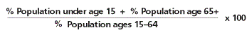
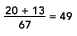
For the U.S., 20% of the population is under 15 and 13% is over 64.
The dependency ratio for the U.S. is 49:100.

This means that there are 49 “dependent” people for every 100 “working” persons in the United States.
The (total) dependency ratio can be disaggregated into the child dependency ratio:
AND the aged dependency ratio:

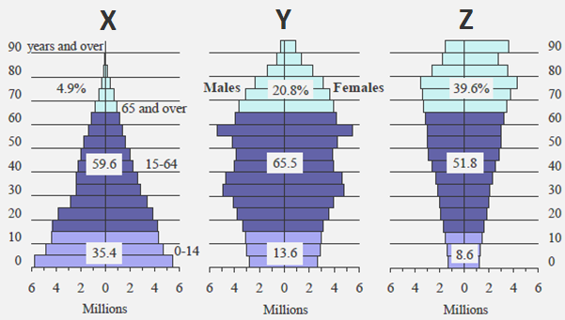

Calculate the overall, youth and aged dependency ratio for the ACTUAL (REAL LIFE, PRESENT DAY) countries represented by population pyramids X, Y and Z above (round to the nearest whole percentage, see examples):
Region | % pop < 15  (A) | % pop > 64  (B) | Total % dependent  - + (B) = (C) | Productive population %  (100% – C) = (D) | Overall  Dependency ratio | Child dependency ratio | Aged dependency ratio
World | 26 | 8 | 34 | 66 | 51:100 | 39:100 | 12:100
MDCs | 16 | 16 | 32 | 68 | 47:100 | 23:100 | 23:100
LDCs | 29 | 6 | 35 | 65 | 54:100 | 45:100 | 9:100
Country X | 35 | 5 | 40 | 60 | 67:100 | 58:100 | 8:100
Country Y | 14 | 21 | 35 | 65 | 54:100 | 22:100 | 32:100
Country Z | 9 | 39 | 48 | 52 | 92:100 | 17:100 | 75:100

According to the table you completed
- What stage of the Demographic Transition Model (DTM) would you find country X? 2 Y? 4 Z? 5
- In which country is the OVERALL pressure to provide for nonproductive citizens the highest? Z
- Which country has the “healthiest” (or lowest) overall dependency ratio? Y
- Which country has the highest “aged dependency” ratio? Z
- DESCRIBE CURRENT socio-economic problems regions with higher “aged dependency” ratios experience. (3)
Regions/countries with higher aged dependency ratios must deal with the socio-economic problem of providing for elderly people. Examples of costs to society of caring for old people include that they need to be provided retirement income/social security, they often have expensive medical/prescription drug costs to treat chronic and degenerative illnesses and as they grow older they may need assistance for daily activities or skilled nursing care. An increasing tax burden will fall on a smaller working age population to fund these needs for the elderly.
- EXPLAIN FUTURE economic problems that a stage five country might experience (think about the Japan video we watched and the concept of a population pyramid as an “up escalator” from which you can predict future situations). (3)
Future problems that a stage five country may experience mostly stem from their shrinking workforce. A country with a declining population will also have a shrinking workforce. This affects these societies in two ways. First, they will have less working citizens to pay taxes to fund social programs to support their elderly dependency needs. In addition, they will have less people available to fill jobs needed in society and basic services not being met. These jobs will often be the low paying tertiary jobs as the shrinking workforce will opt to take higher paying quaternary and quinary jobs. Examples could include fast food workers, convenience store clerks, farm labor, bus drivers, etc. Less workers could also lead to lower GNI per capita resulting in economic decline.
- Which country has the highest “child” or “youth” dependency ratio? X
- DESCRIBE CURRENT socio-economic problems regions with high “child” or “youth” dependency ratios experience. Current socio-economic problems that regions/countries with high youth dependency would be providing for the needs of a high population of younger people. These costs include the cost of daycare, education, medical needs such as prenatal care, immunizations, etc., shelter, clothing and food. This will often divert funds from other areas of need for the country like economic development and will require working age people to pay more of their income in taxes. (3)
- EXPLAIN a FUTURE economic problem these countries could face as these youth cohorts reach adulthood (think about the “up escalator” analogy. This should be a different explanation than the demographic trap below)? A future economic problem that the countries with a high youth dependency will experience is a lack of jobs and economic opportunity for these youths as they become young adults. This country’s population will be exceeding its carrying capacity (in terms of economic opportunity/jobs) and will be experiencing overpopulation. There will be high unemployment among young adults in the country which could lead to out-emigration (and consequently brain drain) as a corrective action or could destabilize the society as young people express their discontent with the government or society in general for their lack of economic prospects. (3)
- EXPLAIN the “demographic trap” (google and read the Wikipedia explanation, it is acceptable. Or use the notes from my lecture, but answer the question in your own words in paragraph form without diagramming it. Make sure your answer reflects the “circular” nature of the trap otherwise it is incomplete). (6) The demographic trap occurs in some LDC countries that have entered stage two of the demographic transition. Medical advancements diffused after WWII from more developed countries to less developed countries. This resulted in rapidly declining crude death rates (1). But because these countries were still underdeveloped, (high Gender Inequality Index and largely reliant on subsistence farming) children were viewed as economic assets and crude birth rates remain high (1). This leads to a very high youth dependency. As a result the country must spend a lot of money on youth services such as food, clothing, shelter, daycare and education for young people (1). This diverts money from investment in economic growth such as infrastructure (roads, bridges, railroads, ports, etc.) (1). Therefore the country remains underdeveloped (1) and reliant on subsistence farming. Subsistence farmers continue to view children as economic assets which reinforces the high crude birth rate, starting the cycle over again (1).

