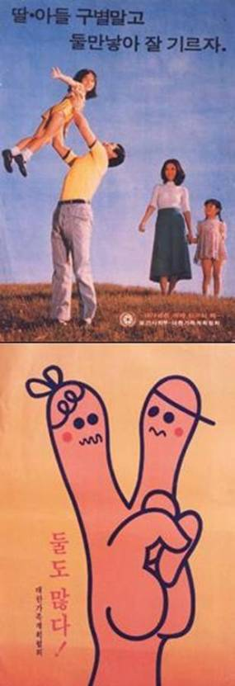
SMALLER FAMILIES AND ECONOMIC DEVELOPMENT IN THE 1960S AND 1970S
Following the Korean War in the early 1950s, South Korea’s population remained primarily rural and agricultural. Its TFR exceeded six children per woman.
In 1962, South Korea began its national family planning campaign to reduce women’s unwanted births through a program of information, basic maternal and child health services, and the provision of family planning supplies and services. The program was seen as essential if the goals of economic growth and modernization were to be achieved.
Overall, the public responded well to the idea of a “small and prosperous family.” By 1970, the TFR had fallen to 4.5 against a background of rapid industrialization and the waning of the country’s largely agrarian character. A 1974 poster (see figure’s top image) exhorted, “Sons or daughters, let’s have two children and raise them well.” In 1981, the government, buoyed by its success up to that point, set a target of a two-child, “replacement” level fertility by 1988 with a program of economic incentives. There was even some mention of a one-child family: “Even two children per family are too many for our crowded country” (see bottom image).² While such a saying may have seemed at least somewhat extreme at the time, it proved to be surprisingly prophetic. The two-child target was met remarkably quickly: The TFR was down to 1.74 by 1984.

South Korean Government Posters Promoted Smaller Families in the 1970s and 1980s

The consequences of violating China's one-child policy were sometimes horrific
Barbara Tasch Oct. 30, 2015, 11:04 AM
The Chinese Communist Party said this week it's lifting its 35-year-old one-child policy and will now allow all couples to have two children. While the world was aware of China's one-child policy, the actual consequences of violating it were opaque to many Westerners.
To be clear, not everybody in China had to comply with the policy. In 2007, the Chinese newspaper China Daily claimed that less than 40% of the population was subjected to the policy. Many minority groups were exempt from the one-child limit, according to China Daily. Moreover, many couples who were both only children were allowed to have two kids even during the era of the one-child policy.
Yet, the people who were subjected to the policy often received inhuman treatment when they broke it. The methods used to enforce the policy ranged from the wide distribution of diverse contraceptive methods; financial sanctions; and forced abortions and sterilizations for those who did not comply, according to the Encyclopaedia Britannica.
In 2013, the Chinese government revealed that 336 million abortions and 196 million sterilizations had been performed since the early 1970s, when the country began moving to limit its population, according to the Financial Times (FT). (The one-child policy was officially put into place at the end of that decade.) The FT also reported that 403 million intrauterine devices had been inserted in women in that time, often forcefully.
A 2013 article for the Guardian by journalist Ma Jian exposes the harrowing treatment women in Bobai County in the Guangxi province were subjected to after local authorities "launched a vicious crackdown on family-planning violators" in 2007. According to the article, 17,000 women in the county were forced to have abortions and sterilized. Local officials reportedly collected money even from families who had already been fined and looted the homes of those who did not have enough money to pay.
One of the women interviewed said officials took her from her home, kicked her in the belly, and forced her to go to the hospital — where her fetus was aborted and she was sterilized. Every women in the county was sterilized, she said.
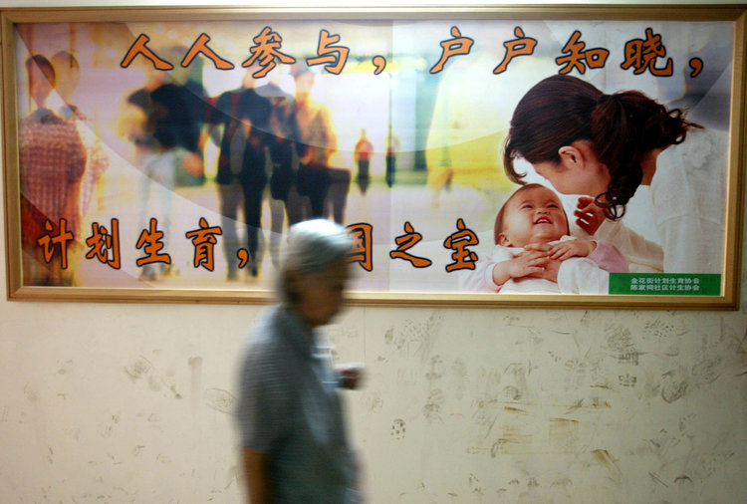
Another woman said she was forced to have an abortion when she was over eight months pregnant. "He was still alive after the nurse pulled him out from me. He was a tough little creature. He clutched the nurse's sleeve and wouldn't let go. She had to peel his fingers off her one by one before she could drop him into the bin," the woman told Jian.
The crackdown led to the biggest protests China had seen since the unrest in Tiananmen Square in 1989. Thousands of protesters torched government buildings in Bobai County to fight against the crackdown, according to the Guardian.
Yet, China only apparently changed its policy because its population is aging and it needs an infusion of young people to sustain its economy. Abandoning the policy will "increase labor supply and ease pressures from an aging population," the National Health and Family Planning Commission, which enforces the policy, said in a statement cited by The New York Times. "This will benefit sustained and healthy economic development," the commission said.
The struggle for reproductive freedom in China is not over yet, though. The Chinese government still allows just two children per couple, meaning the government will still be involved in some of its citizens' most intimate choices.

