20th Century Global Migration Streams Activity

Instructions: Below are a selection of 20th century migration streams. In your groups, answer all parts of each question on a separate sheet of paper. Be sure to write in complete sentences with the level of breadth & depth required by the prompt and task word (identify, explain, describe).
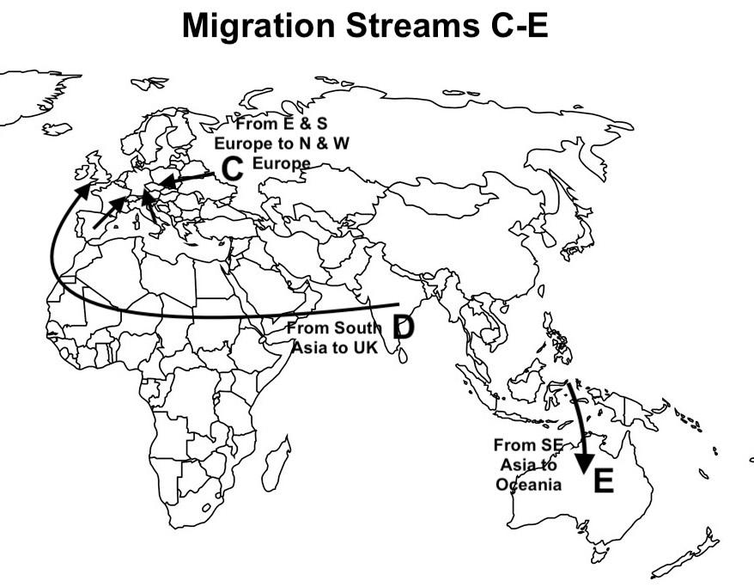
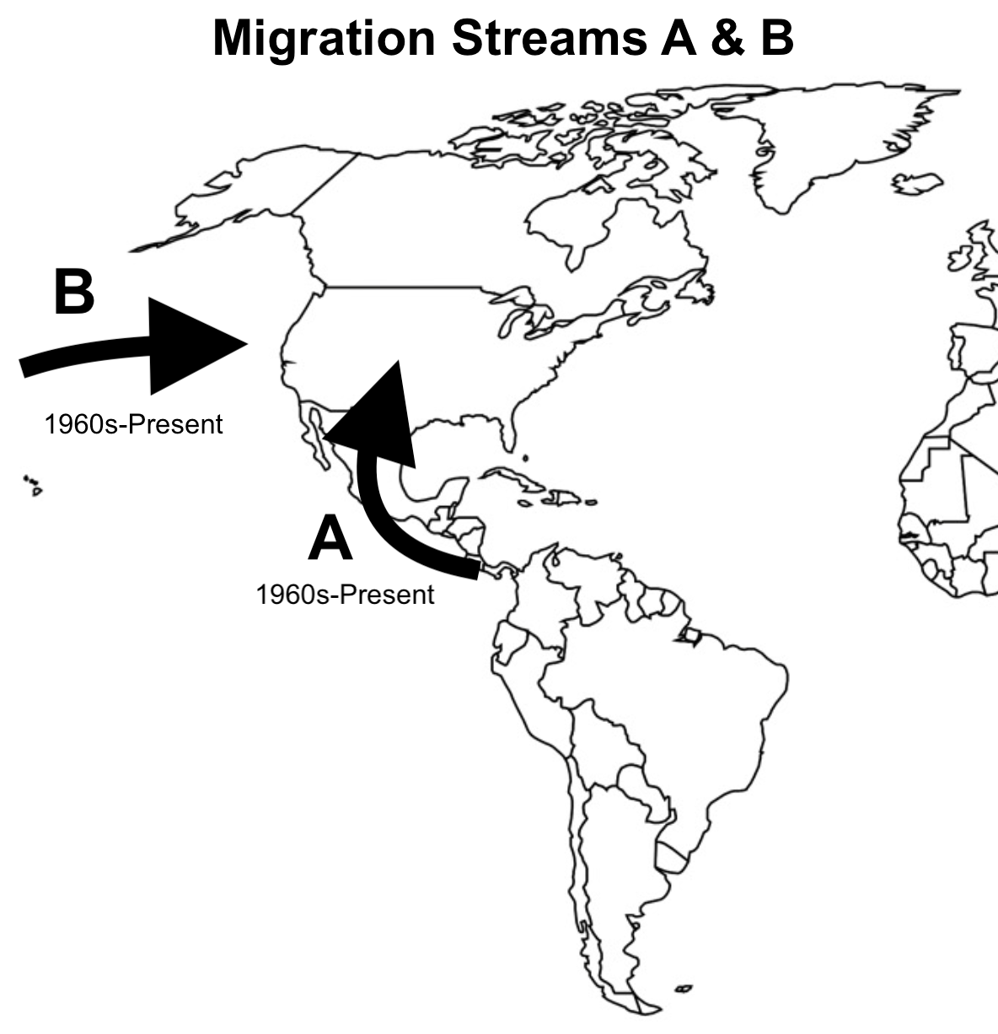
Question 1 (Migration Streams A-E):
- IDENTIFY the COMMON general PULL factor for migration streams A-E.
The common pull factor for streams A-E would be the improvement in the migrants’ standard of living, economic advancement, wealth, prosperity etc. (1)

- EXPLAIN the COMMON economic/demographic PUSH factors for migration streams A, B, D & E.
The common economic/demographic push factor for A, B, D & E is stage two overpopulation. This occurs in LDCs when medical advancements diffuse from the more developed world lowering deaths rates. Since there is no economic development, parents continue to see children as economic assets and the crude birth rate remains high. This leads to exponential population growth. The population then begins to exceed the carrying capacity of the country. Leading to a needed corrective action (other than increased death rates, hopefully). This corrective action comes in the form of emigration usually towards wealthier MDCs (5)

- EXPLAIN the economic situation that is causing migration stream C, SPECIFICALLY from Eastern Europe.
Eastern Europe is less wealthy and developed than Western Europe. This is due to several factors but most importantly, Eastern Europe was under the domination of the Soviet Union and the communist economic system during the 2nd half of the 20th century. Although this improved some areas of life it lagged behind the consumer focused and materially prosperous west. Furthermore, in the late 1980s and early 1990s, communism fell and these societies transitioned to market economies. Although in the long run this will be beneficial, the change was difficult. Inefficient government-run businesses and industry were closed and many workers were left unemployed and without a way to support themselves. This has caused many Eastern European to seek better economic opportunities in the West.

- DESCRIBE one benefit for the SOURCE countries as a result of migration streams A, B, D, & E (do not repeat your answer to B).
One benefit other than relief from overpopulation pressures experienced by the source countries like A, B, D & E in relation to economic migration streams are remittances. Remittances are money sent back by migrants to their families in the source country. Many source countries rely heavily on these remittances. An example of dependence on remittances by an immigration source country is El Salvador. El Salvador depends so much on remittances that they chose to abandon their national currency and instead use the American dollar.

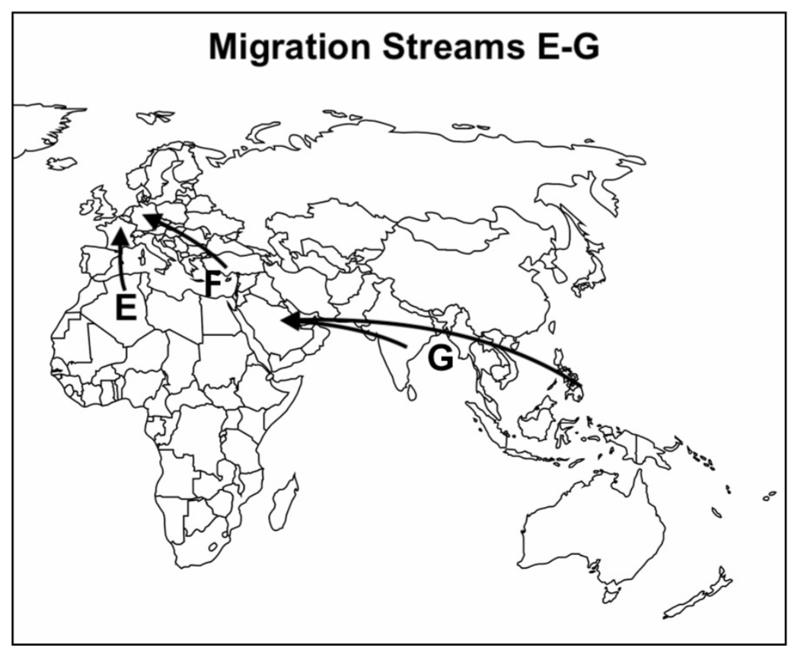

Question 2 (Migration Streams E-G): *Note: Migration Stream E above is different from Stream E in Question 1.
- IDENTIFY the programs which became a COMMON PULL FACTOR for migrations E-G. (see Rubenstein p 108, GR#12)
The common pull factor for migration streams E-G are guest worker programs.
- In general, briefly DESCRIBE the role fulfilled by these migrants in migration streams E-F. Provide more specific detail for migration G (hint: see Guided Reading #12).
Guest workers work in low wage, low skill jobs like sanitation workers, construction, food service and hospitality and leisure.
- EXPLAIN the migration stream G and its effect on the population pyramids of the destination countries (Guided Reading #8ciii & attached population pyramid)
Migration stream G represents guest workers from the Philippines and South Asia migrating to the Persian Gulf States largely to work in the dangerous and dirty jobs in oil drilling and in construction projects. The presence of these guest workers can be seen in the population pyramid of The United Arab Emirates through the large bulge of males in the working age cohorts. Thus also reflects the fact that Persian Gulf states have the highest proportion of immigrants in their countries compared to native born populations.
- With reference to the DTM, DESCRIBE the demographic/economic problem migration streams E-F help to alleviate for the DESTINATION countries (powerpoint/discussion).
Guest worker programs could help to offset the aging populations of countries in stage four and stage five. Many European countries have progressed into these later stages demographically. As a consequence they have high aged dependency and a shrinking workforce. Guest workers can serve to strengthen the number of working age adults and to help pay taxes that would contribute to supporting the needs of the elderly which include pension and medical care such as skilled nursing and or assisted living as they age.
- EXPLAIN two social/cultural problems facing DESTINATION countries as a result of migration streams E-F.
One problem faced by migrants in destination countries is ghettoization. Migrants (often Muslim) are clustered in high poverty, high unemployment communities that are largely isolated from the general population. Often they reside in government subsidized housing built purposefully on the outer edge of cities so as to not interfere with the country’s tourism industry. This high poverty and isolation often makes immigrants feel like mainstream society has not accepted them and makes them susceptible to radicalization.

One reaction to the migration from within the European Union and from LDCS has been the rise of nativism. Nativism is the belief that native born interests should be supported rather than those of immigrant communities. Examples of the rise of nativism include the Brexit vote in the United Kingdom to leave the European Union and the popularity of right wing nationalist, anti-immigrant politicians like Marine Le Pen in France and Viktor Orban in Hungary.

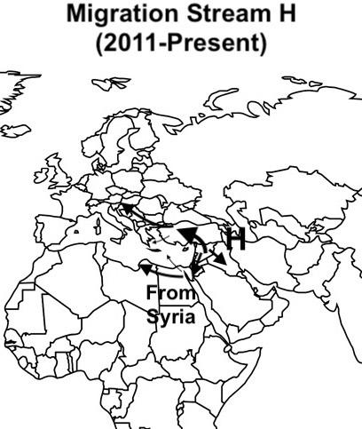
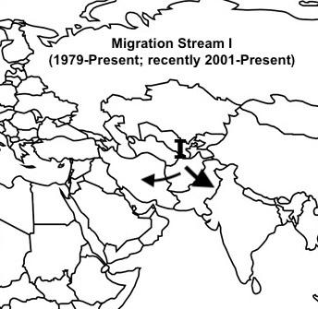

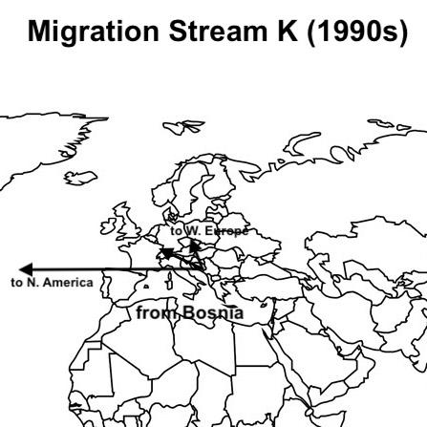
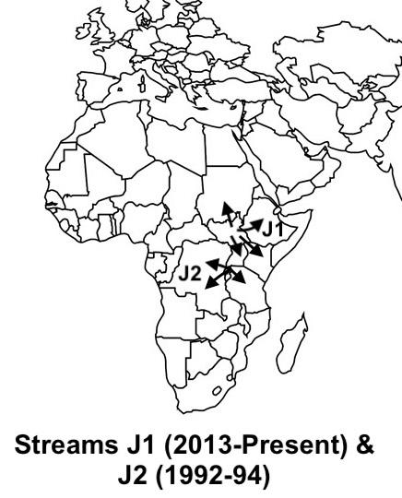

Question 3 (Migration Streams H-K):
- DESCRIBE the COMMON specific PUSH factor for streams (H-K). (see de Blij p 89 - 93, 102 - 107 and GR #21 & 23)
The common push factor for streams H-K is conflict or war. Examples of this include the Syrian Civil War (H), the wars in Afghanistan (I), the Rwandan Genocide (J2) and Sudanese Civil War (JI) and the breakup of the former Yugoslavia (K).
- For migrations H-K, EXPLAIN the importance of the push factor on whether the migrants are allowed entrance into the DESTINATION countries. (see Rubenstein p 94 - 95, 98 - 99, GR #12)
The push factor is important for migrants in streams H-K because if they can prove that they are escaping from harm and cannot return to their home country for fear for their lives then they will be granted refugee status and be given asylum in the destination country. If they can not prove they are fleeing from a conflict or persecution then they will be deemed to be voluntary (usually economic) migrants and not granted asylum but rather have to apply for entry through other means.

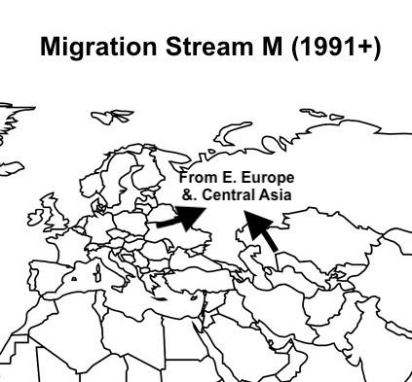

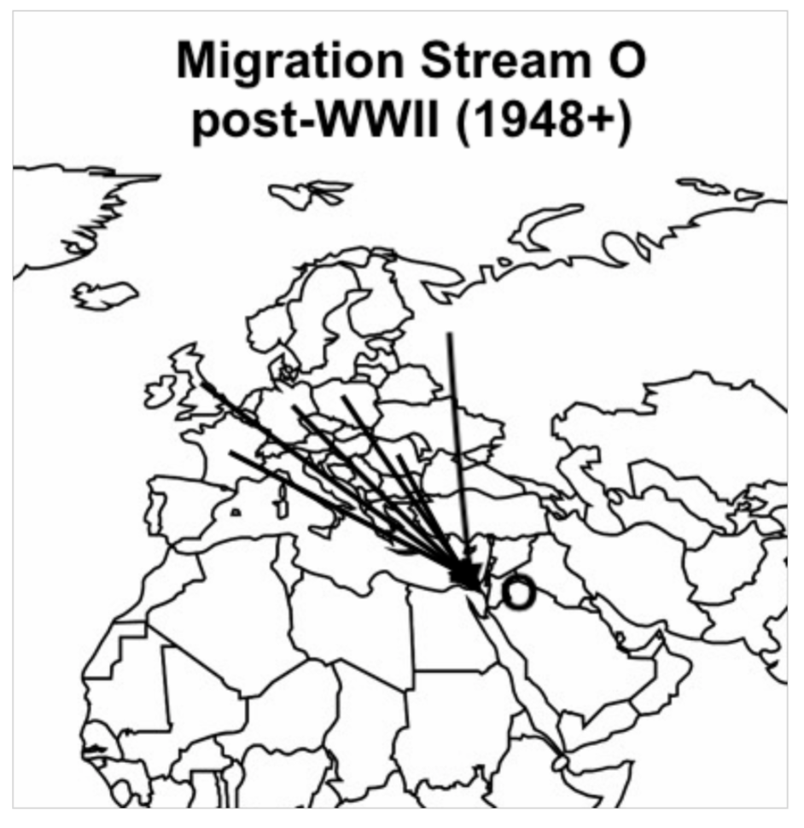

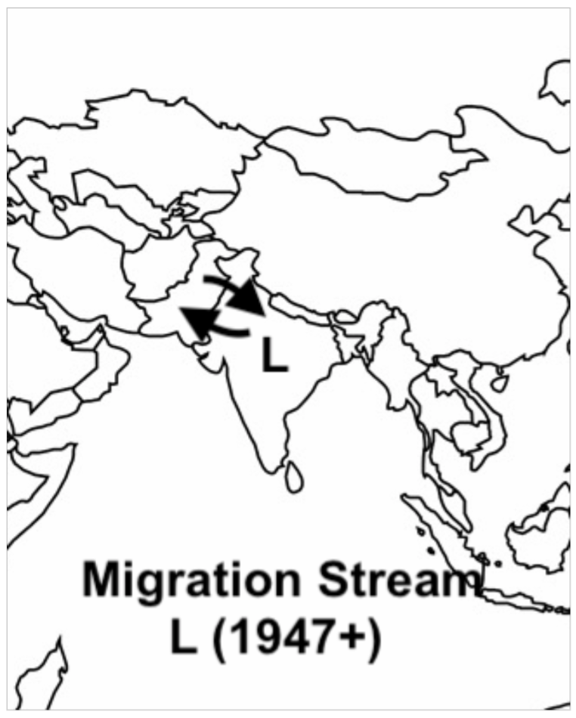

Question 4(Migration Streams L-O):
- IDENTIFY each migration stream. (see Rubenstein p 248, see GR#22-8, de Blij p 97)
Migration stream L represents the migration of Muslims into Pakistan and Hindus into India after the partition of British India in 1947
Migration stream M represents the return of Russian expatriates who had emigrated from Russia during the Russian Empire and Soviet Union to russify areas controlled by Russia. After the fall of communism many of these Russians decided to return to Russia proper rather than remain minorities in newly independent non-Russian states.
Migration stream O represents the immigration of Jews from Europe to the newly established state of Israel in 1948 following WWII and the Holocaust.

- DESCRIBE the COMMON specific PULL factor for streams L-O. (de Bli p 96, GR#21)
The common pull factor for each of the above streams is the reconnection of cultural groups. Each stream represents a group of people who want to move to live alongside people who share their particular culture. See above for three examples.

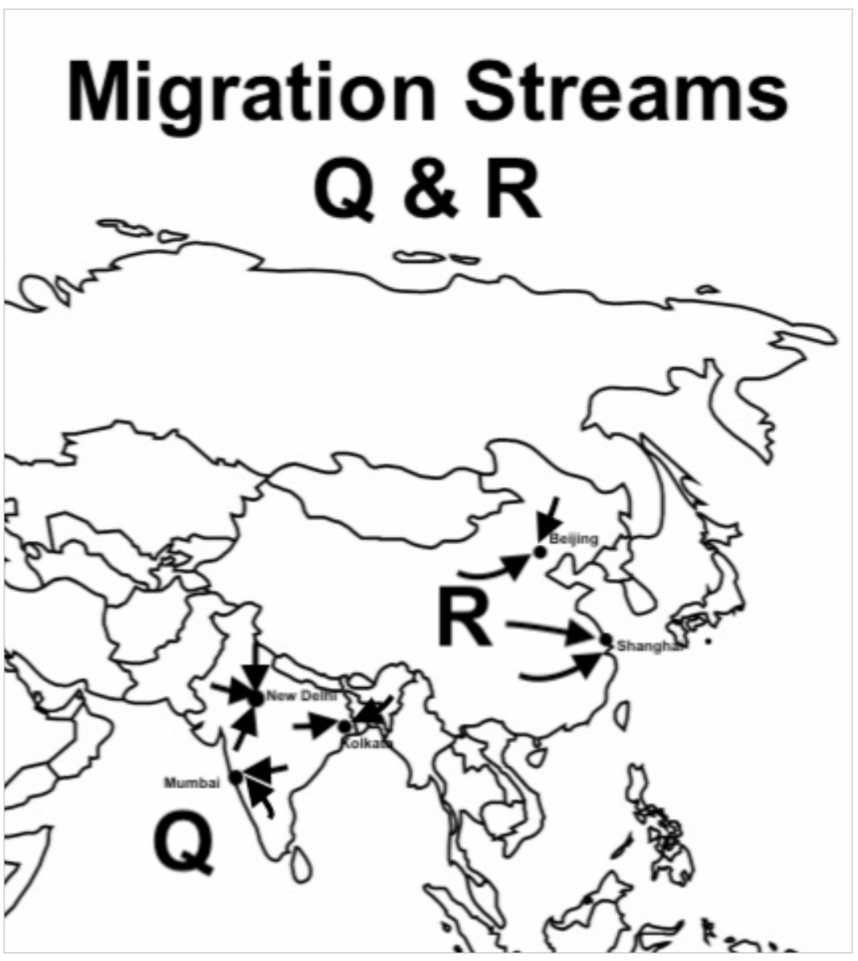
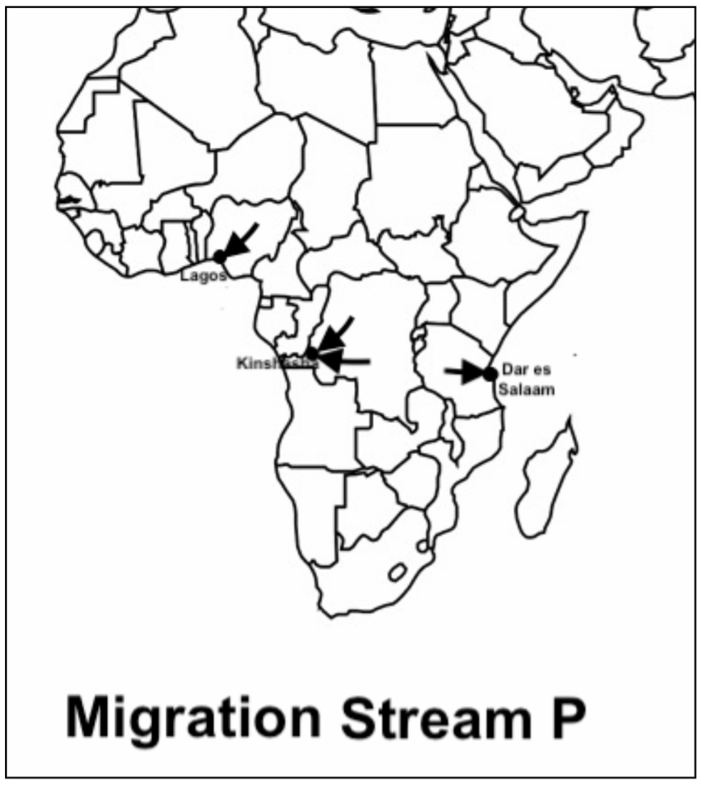

Question 5 (Migration Streams P-R):
- EXPLAIN the COMMON specific migration pattern for migration streams P-R.
(see de Blij p 96)
The common migration pattern for streams P-R is urbanization. Urbanization is the movement of people from rural areas to cities. It is the largest migration flow of people of the world today as people in LDC regions such as China, India and sub-Saharan Africa flock to cities seeking economic opportunities not available in the rural farming economy.

- DESCRIBE the short-term ENVIRONMENTAL PROBLEMS caused by these migration streams. (see Rubenstein p 476)
The short-term environmental problem caused by these migration streams is the creation of informal settlements in rings on the periphery of cities in the developing world. These informal settlements have few services, homes are made from scavenged cardboard, sackcloth, wood boxes and crushed beverage cans. Common latrines are used and there is no running water. Water must be carried from a central well or dispensed from a truck. Electricity may be hijacked and there is no public transport resulting in residents needing to walk hours to their place of employment.

- EXPLAIN the LONG-TERM social and/or demographic effects of these migrations.
The long-term social or demographic effect of urbanization will be a decrease in the crude birth rate (CBR). As people move to cities, they eventually realize that children are economic burdens off the farm and therefore have less children. Furthermore, in cities women are exposed to more secular ideas regarding work and educational opportunities, the availability of contraceptives and female empowerment resulting in them wanting to have less children.

- EXPLAIN how the streams above reflect globalization/core-periphery relationships.
The streams above demonstrate core-periphery relationships because the main beneficiaries of these streams are people living in the core. When transnational corporations move to cities in LDCS, these streams provide them with cheap labor. As a result, consumer products shipped to MDCs (the core) have a lower price. In addition, cheap labor also allows transnational corporations to make a larger profit which is passed along to its executives through bonuses and shareholders through stock price increases and dividends. Both the executives and shareholders most likely live in the core.

